Jocelyn’s Cartoons

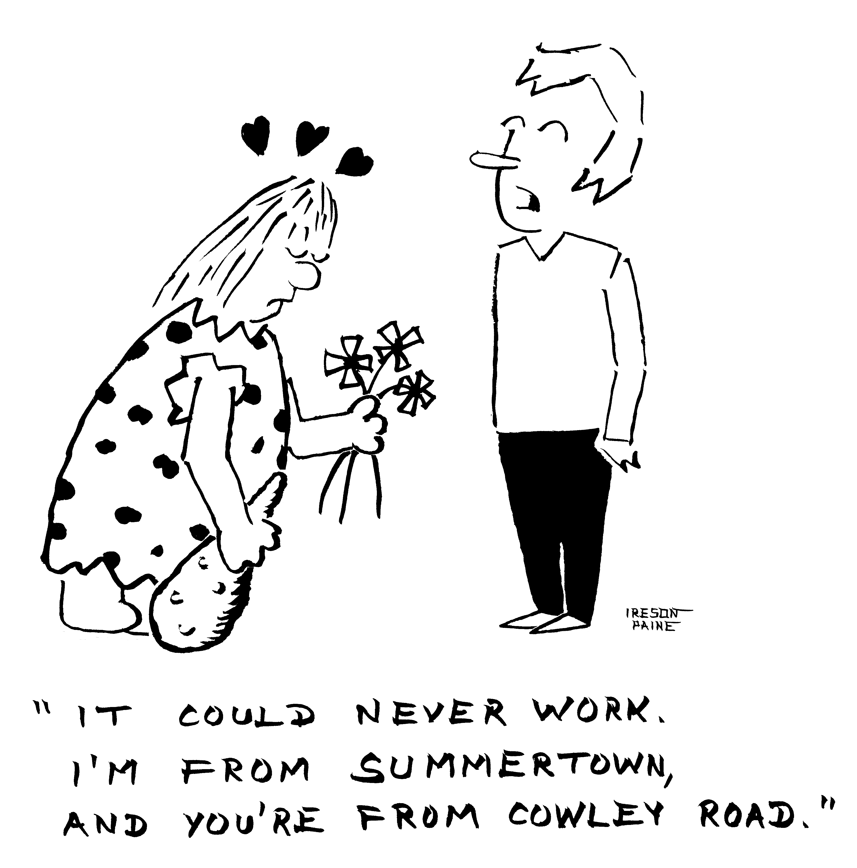

Cartoons by Jocelyn Ireson-Paine
www.j-paine.org

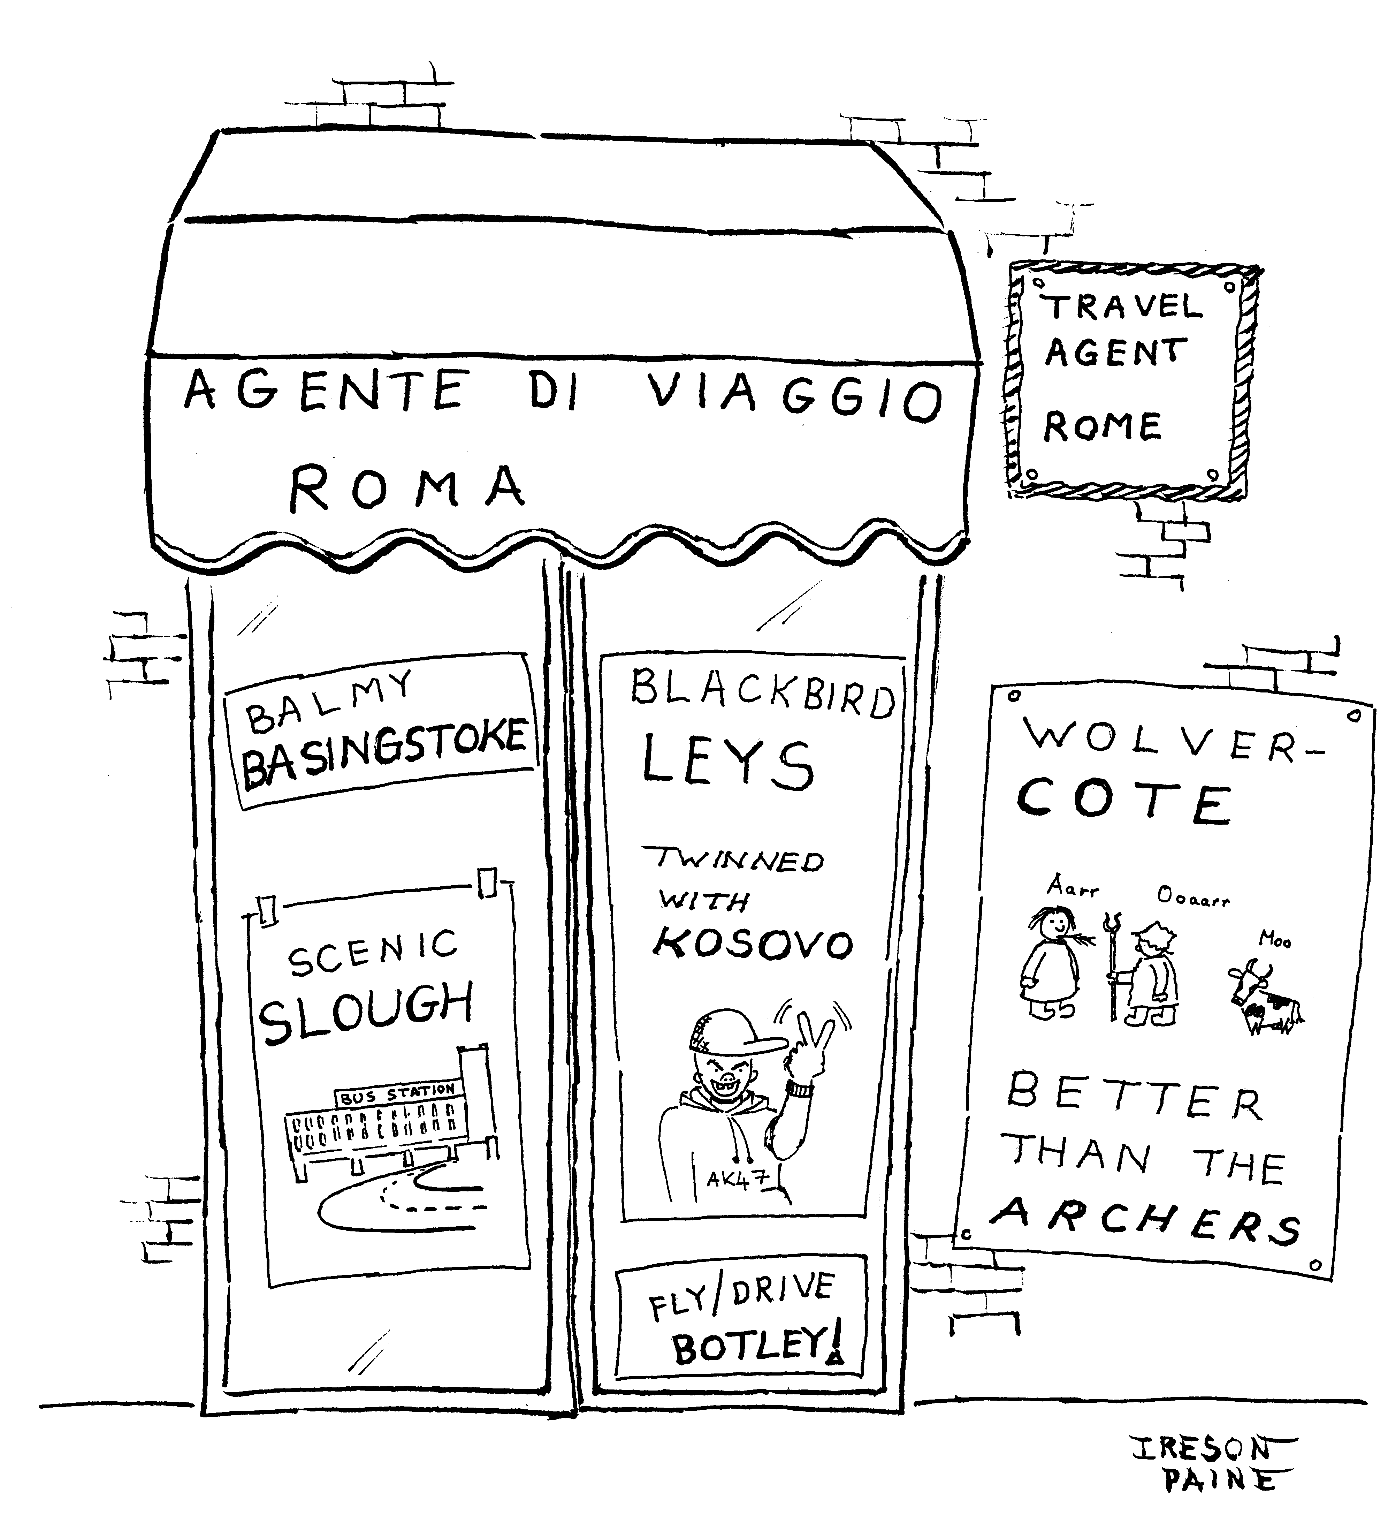

This is an Oxford-themed birthday card for a friend from Wolvercote. I happened to show a copy to Karl who runs the Post Box in Lower Wolvercote, and he liked it so much that he framed it and hung it in the shop. But a customer made him take it down, shouting “How dare you imply Blackbird Leys is a war zone!” In fact though, the name “Kosovo” is short for “Kosovo Polje” (Косово Поље), and means “the field of blackbirds”. Coupled with Blackbird Leys’s reputation, this coincidence was too much to resist.

Like the other cartoons, I drew this with a Pentel Brush pen and fineliner pens.

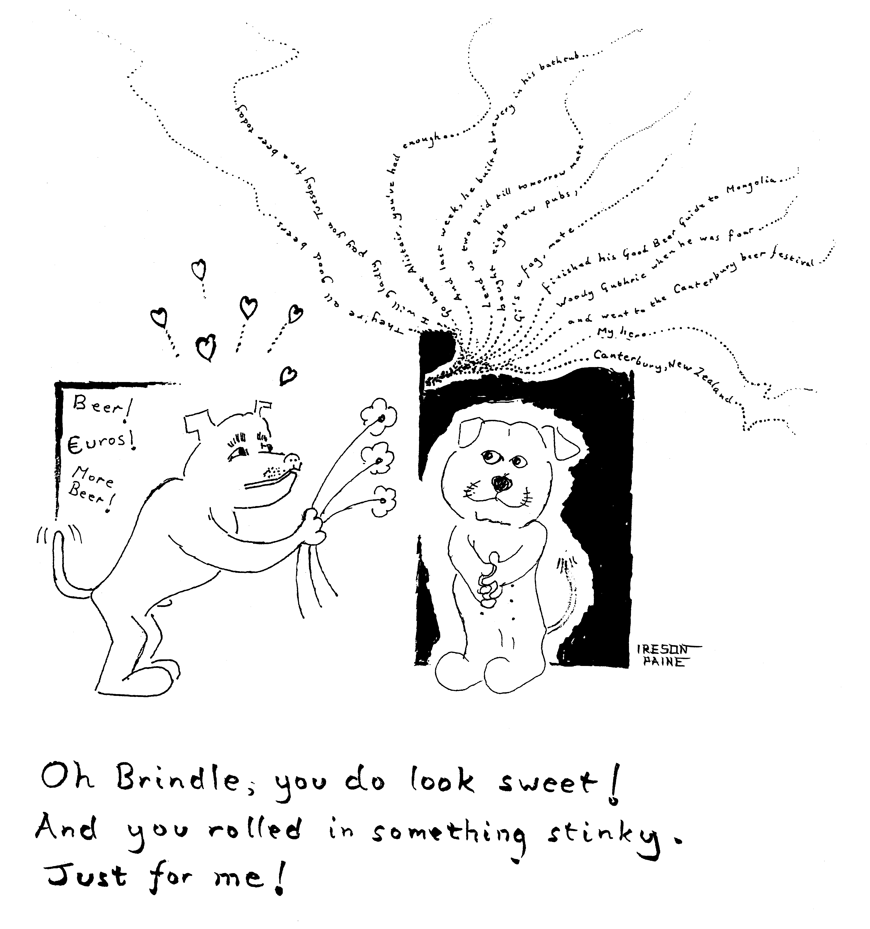

I drew this a few years ago for Tony Flatman, landlord of a pub called the Wharf on Speedwell Street. He had a Staffordshire bull terrier named Brindle, whose habits were peculiarly vile, even for a dog. The notice on the left is the one Tony put up outside his front door: he was the only landlord I know who would accept payment in euros.

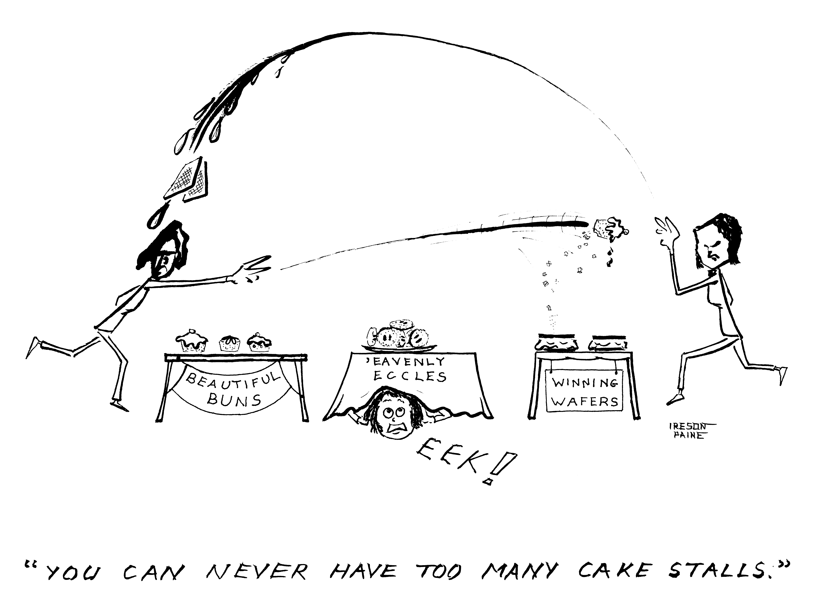

Every Saturday from 10am to 1pm, there is an excellent farmers’ market in the school behind Tesco on Cowley Road. There are many stallholders who sell cakes, so many that they sometimes seem close to coming to blows. I was asked to draw this cartoon for the Lord Mayor Elise Benjamin, who visited the market in July 2011 to commemorate its fifth anniversary.

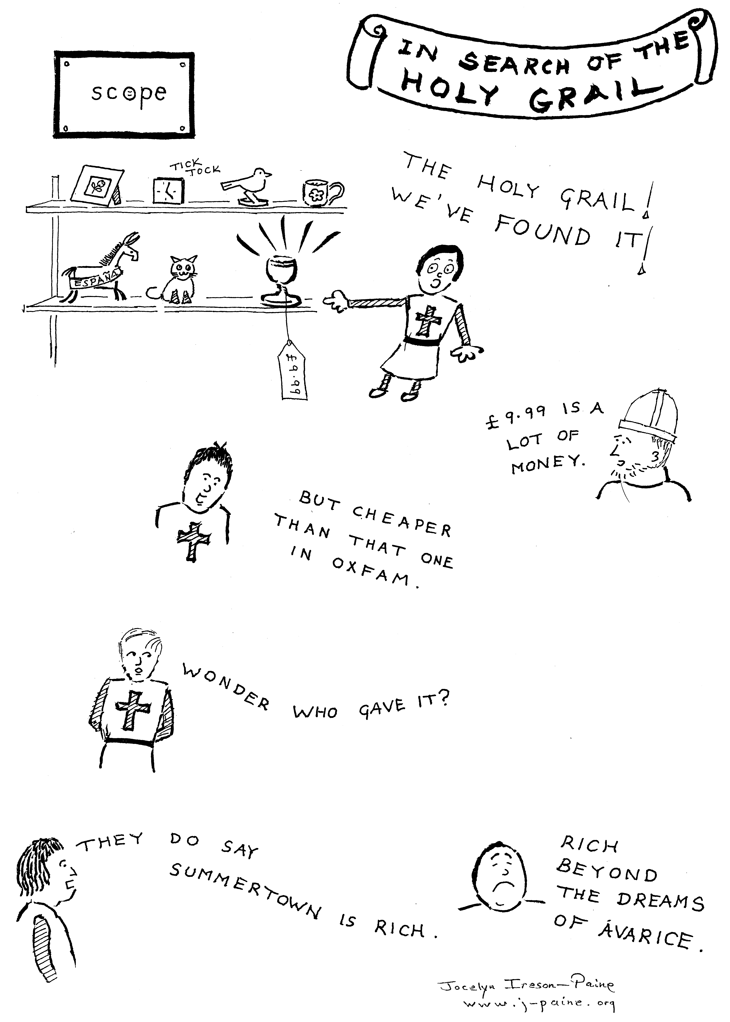

This is a bit of fun drawn for the Summertown Scope shop, for a charity card sale. I was selling my greeting cards outside the shop, and giving half the profits to Scope.

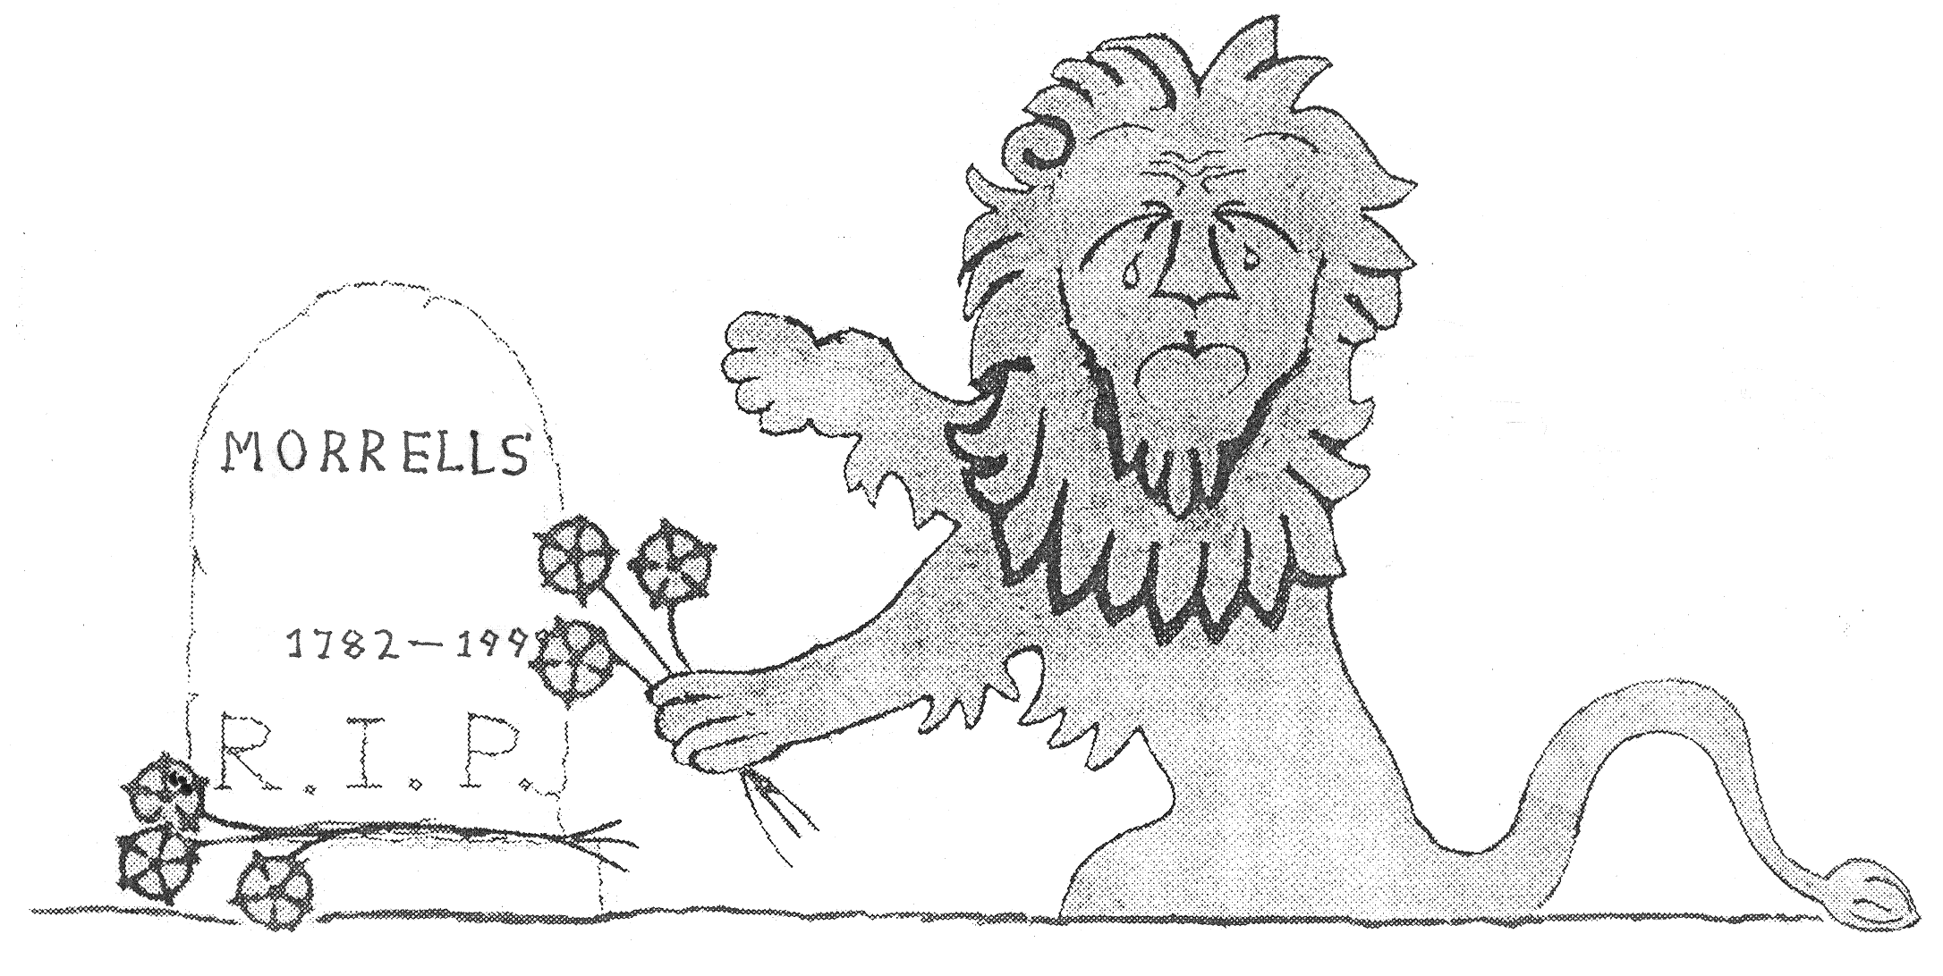

An old drawing in which I adapted the Morrells Brewery lion emblem to mark the brewery's closure. This was after a boardroom battle in which Charles Eld, the final member of the Morrell family to run the brewery, was deposed. The brewery seemed more interested in property than beer: it sold off its pubs, and turned its buildings into flats.

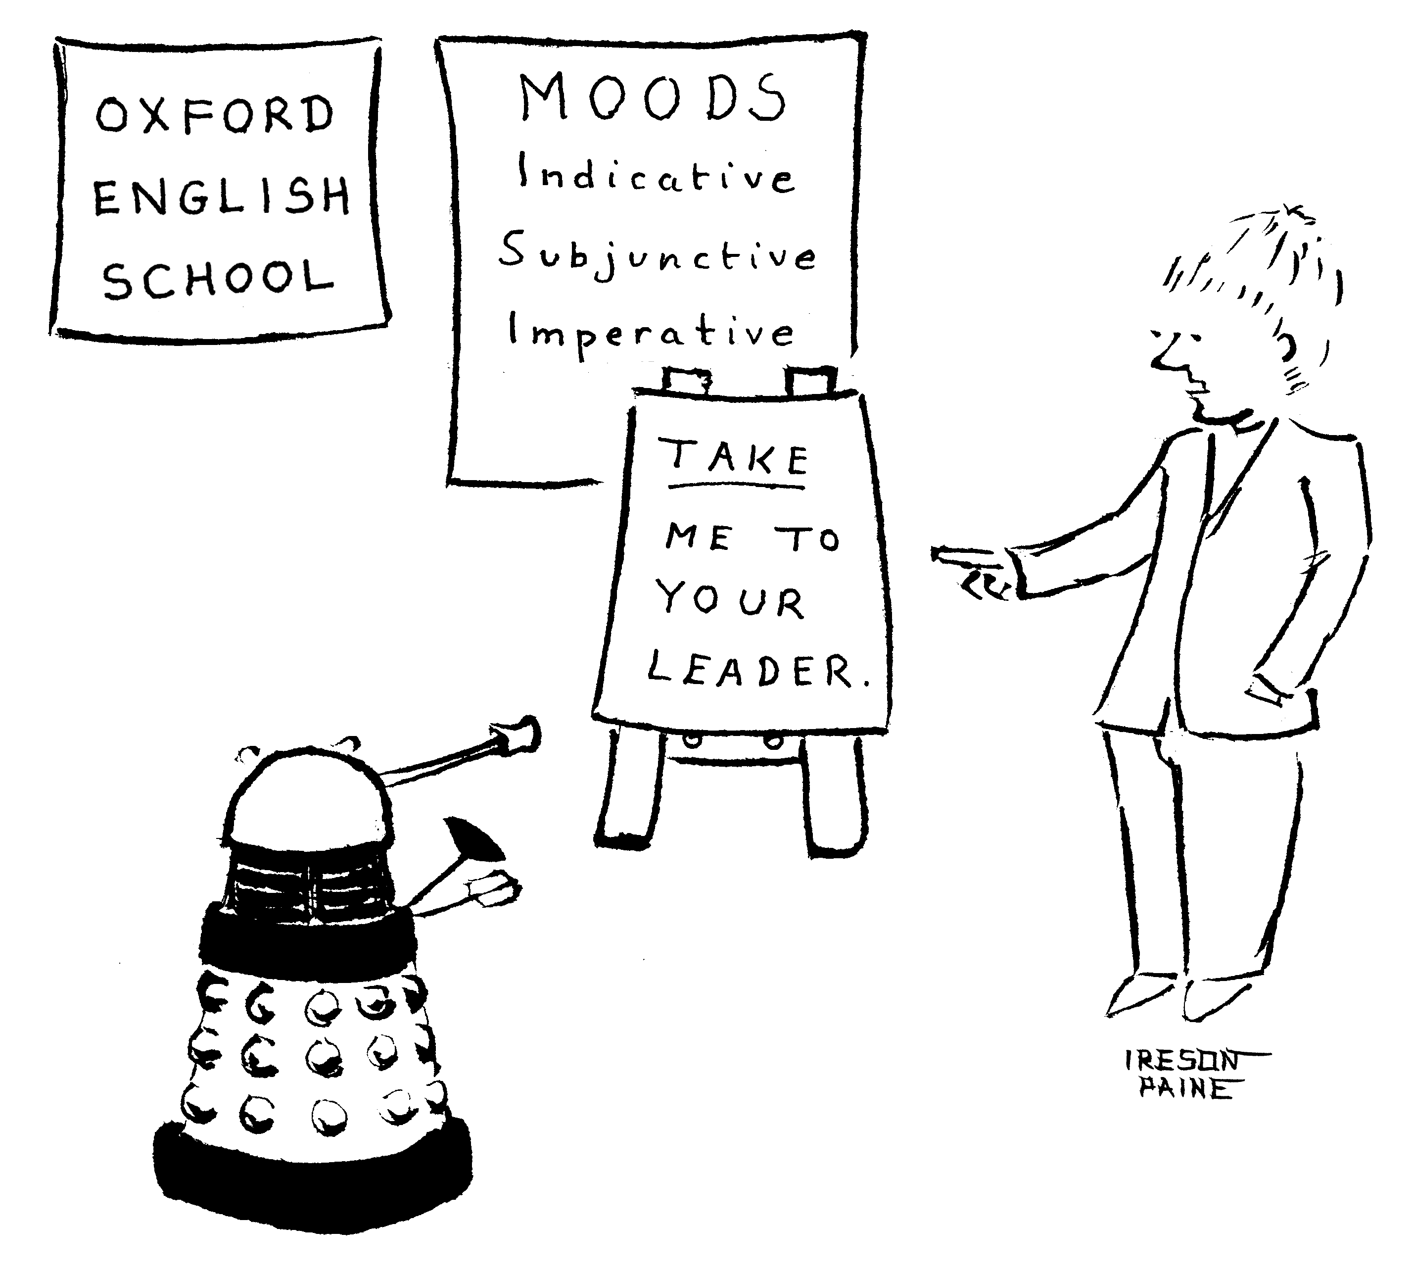

This cartoon was inspired by thoughts of a friend who teaches at one of Oxford’s many English-language schools.

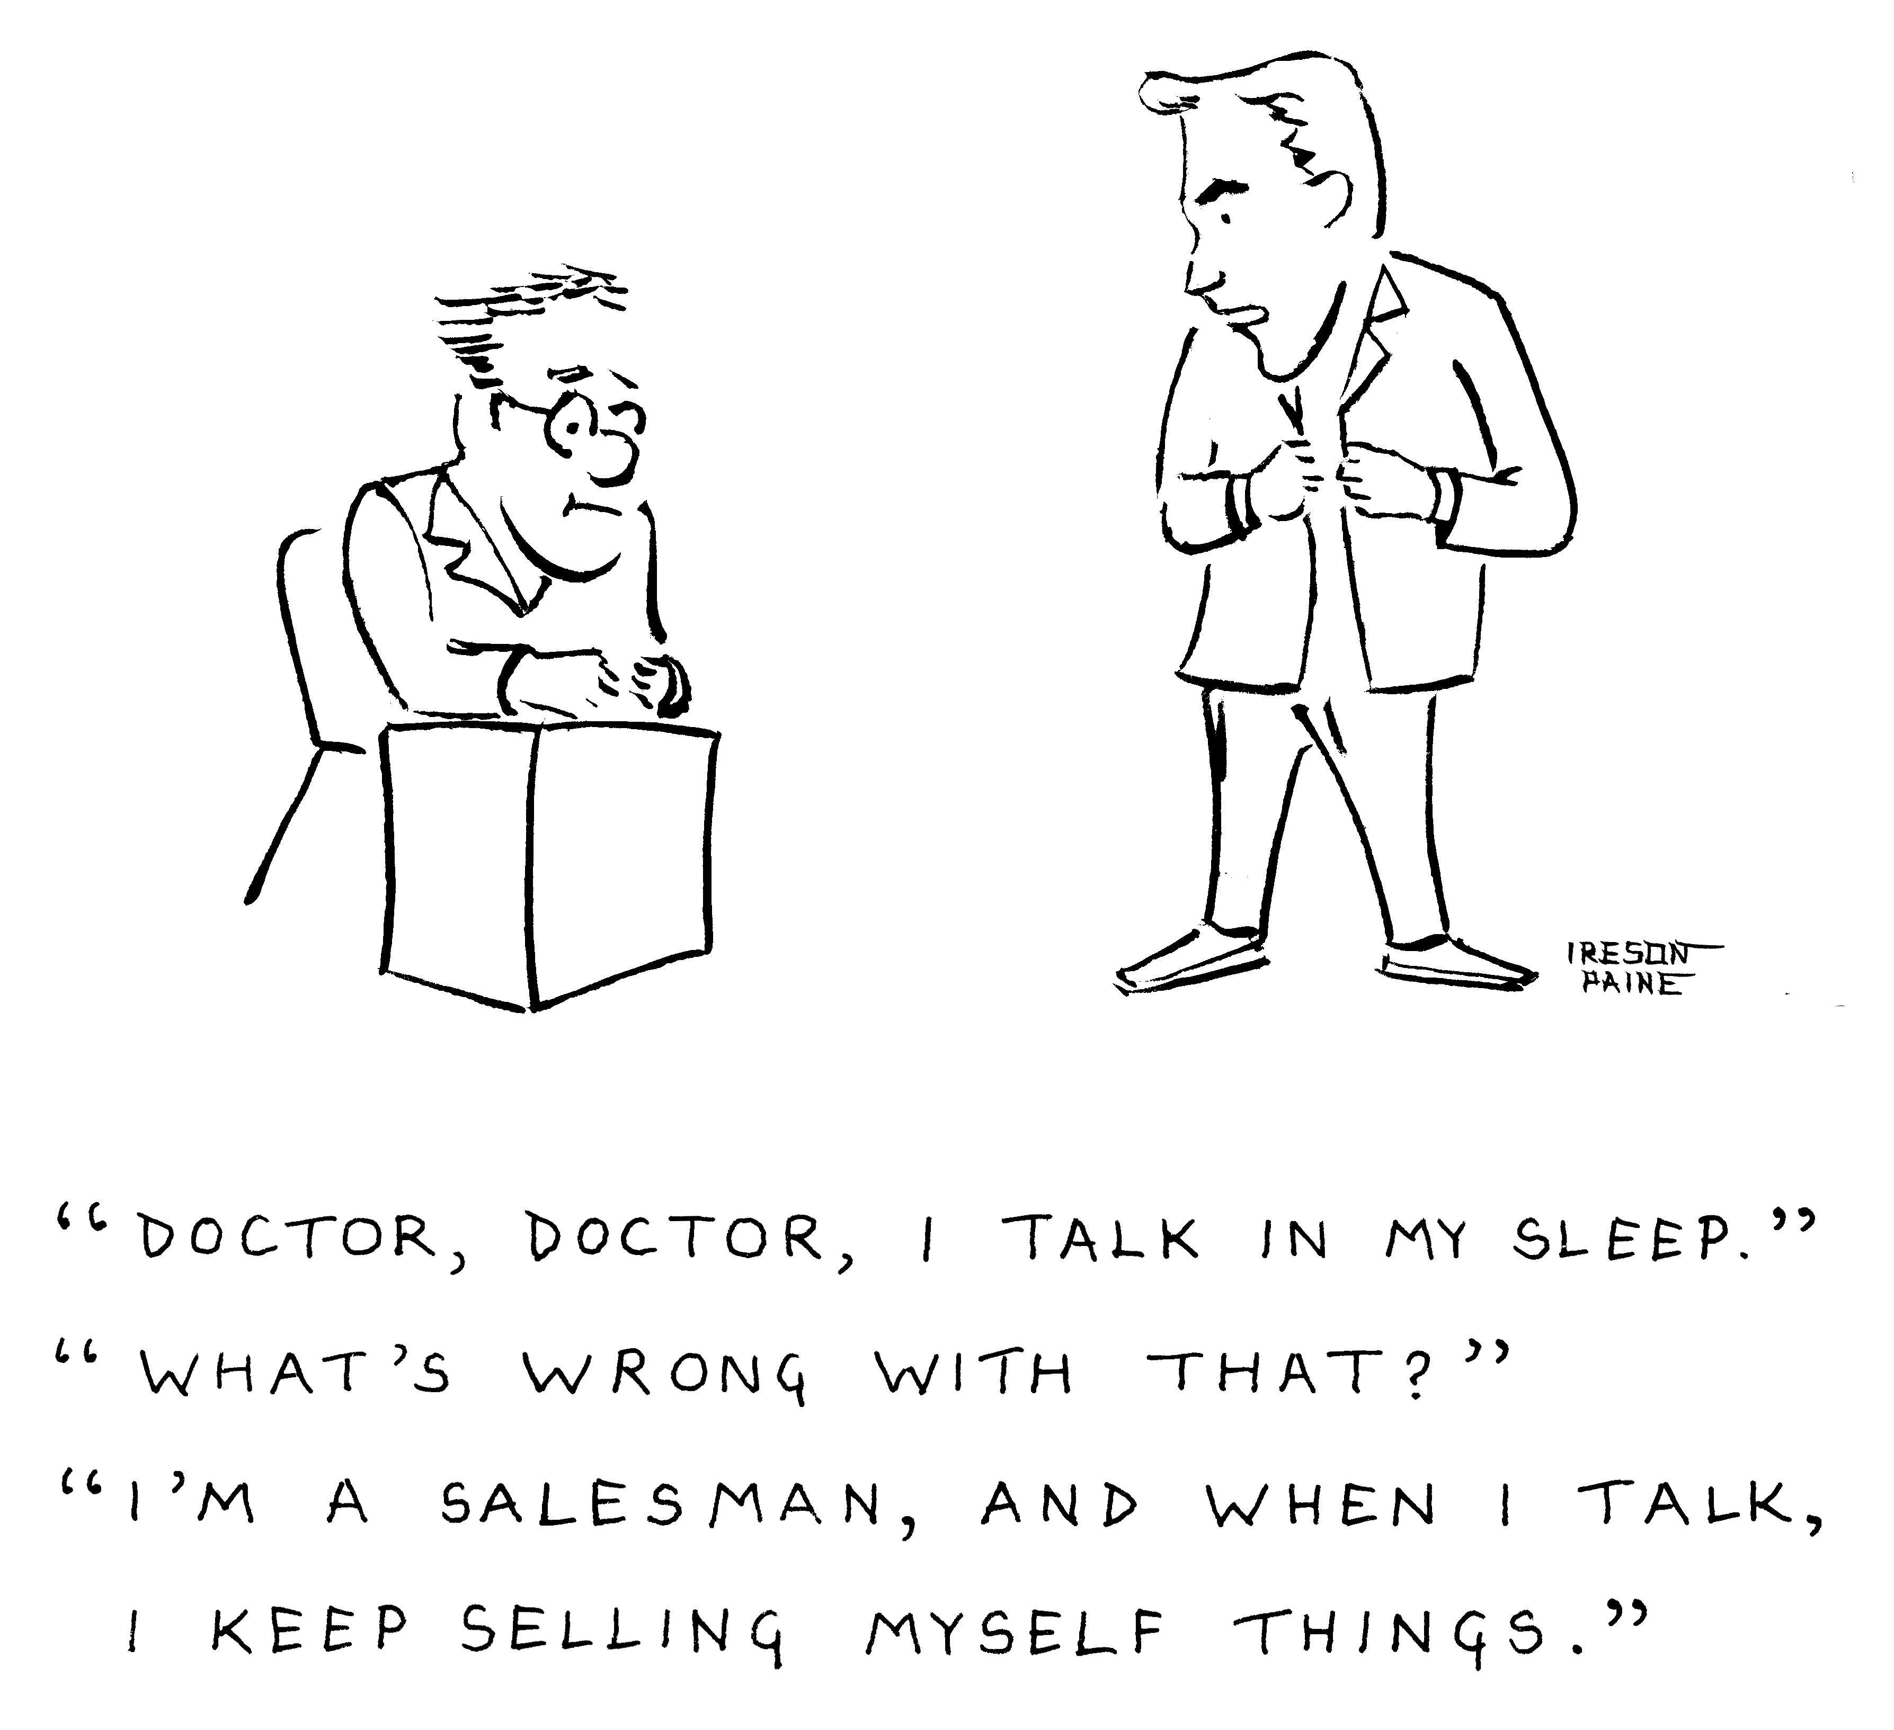

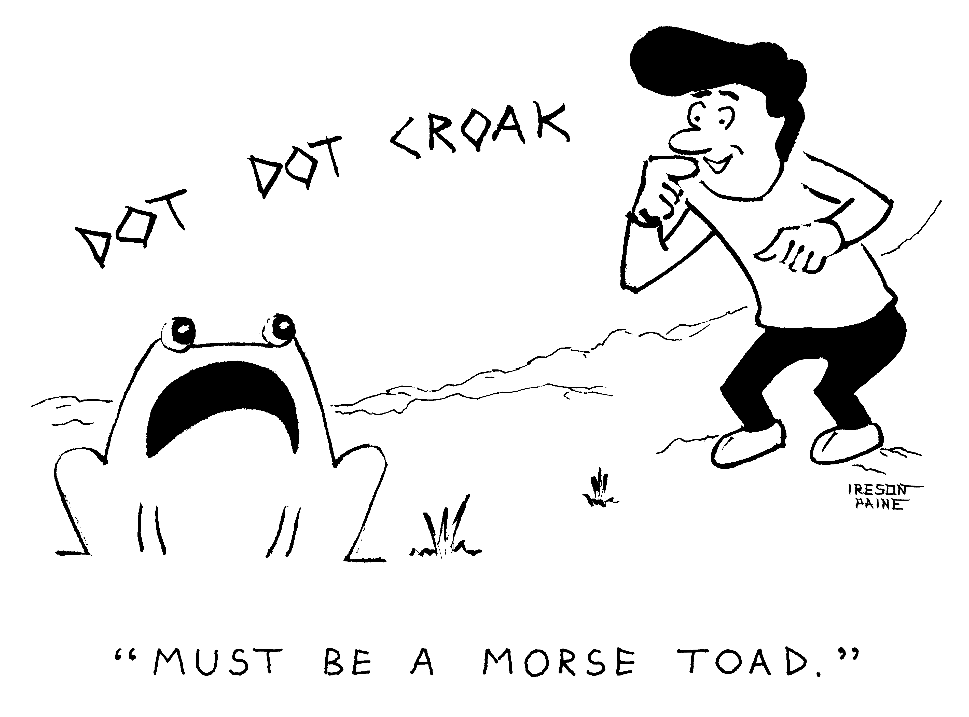

Like the language-school cartoon, this one is a little bit about technology: at least, if you regard Daleks as technology. Unlike it, it isn't about Oxford. Most of the remaining cartoons in this booklet are ones I drew for the online computer magazine Dr Dobbs. I used to teach Artificial Intelligence at the university, which is why some of the cartoons feature robots.

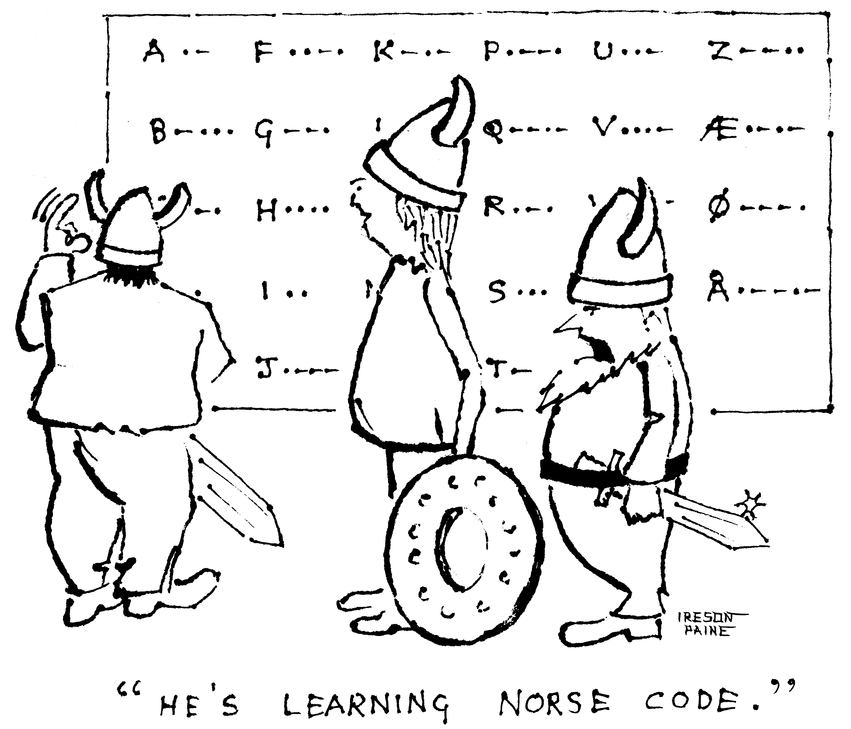

I drew this cartoon onto rice paper. The ink soaking into the paper accounts for the little blobs at the start of the lines, and makes it easy to vary the thickness of lines, giving a nice free style.

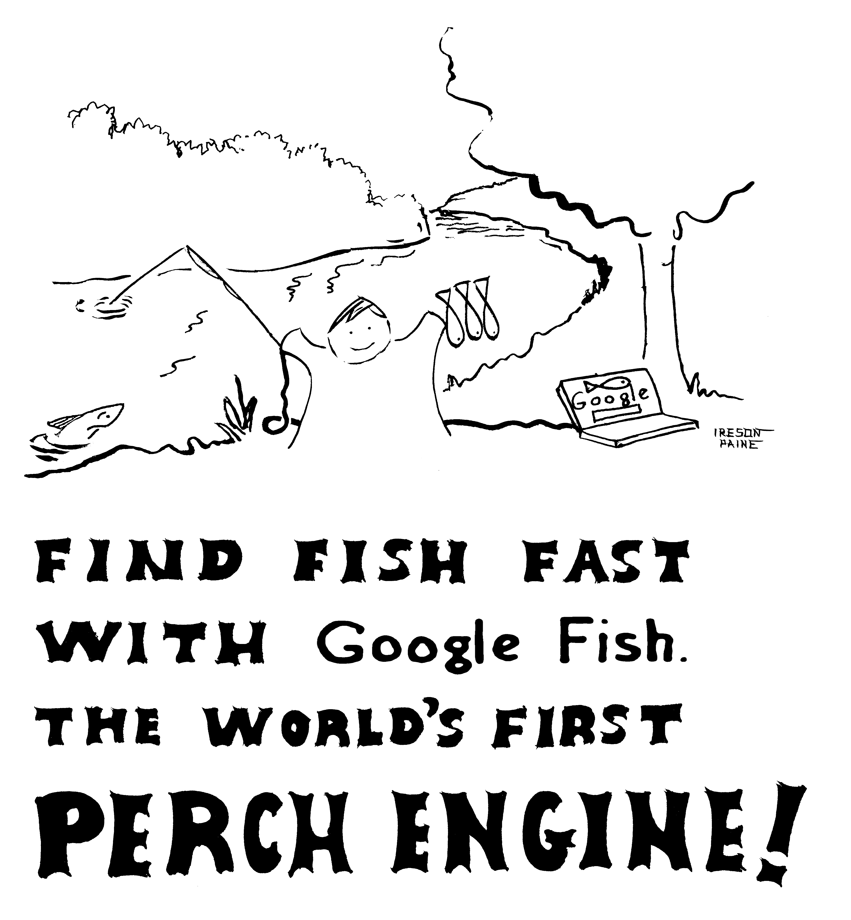

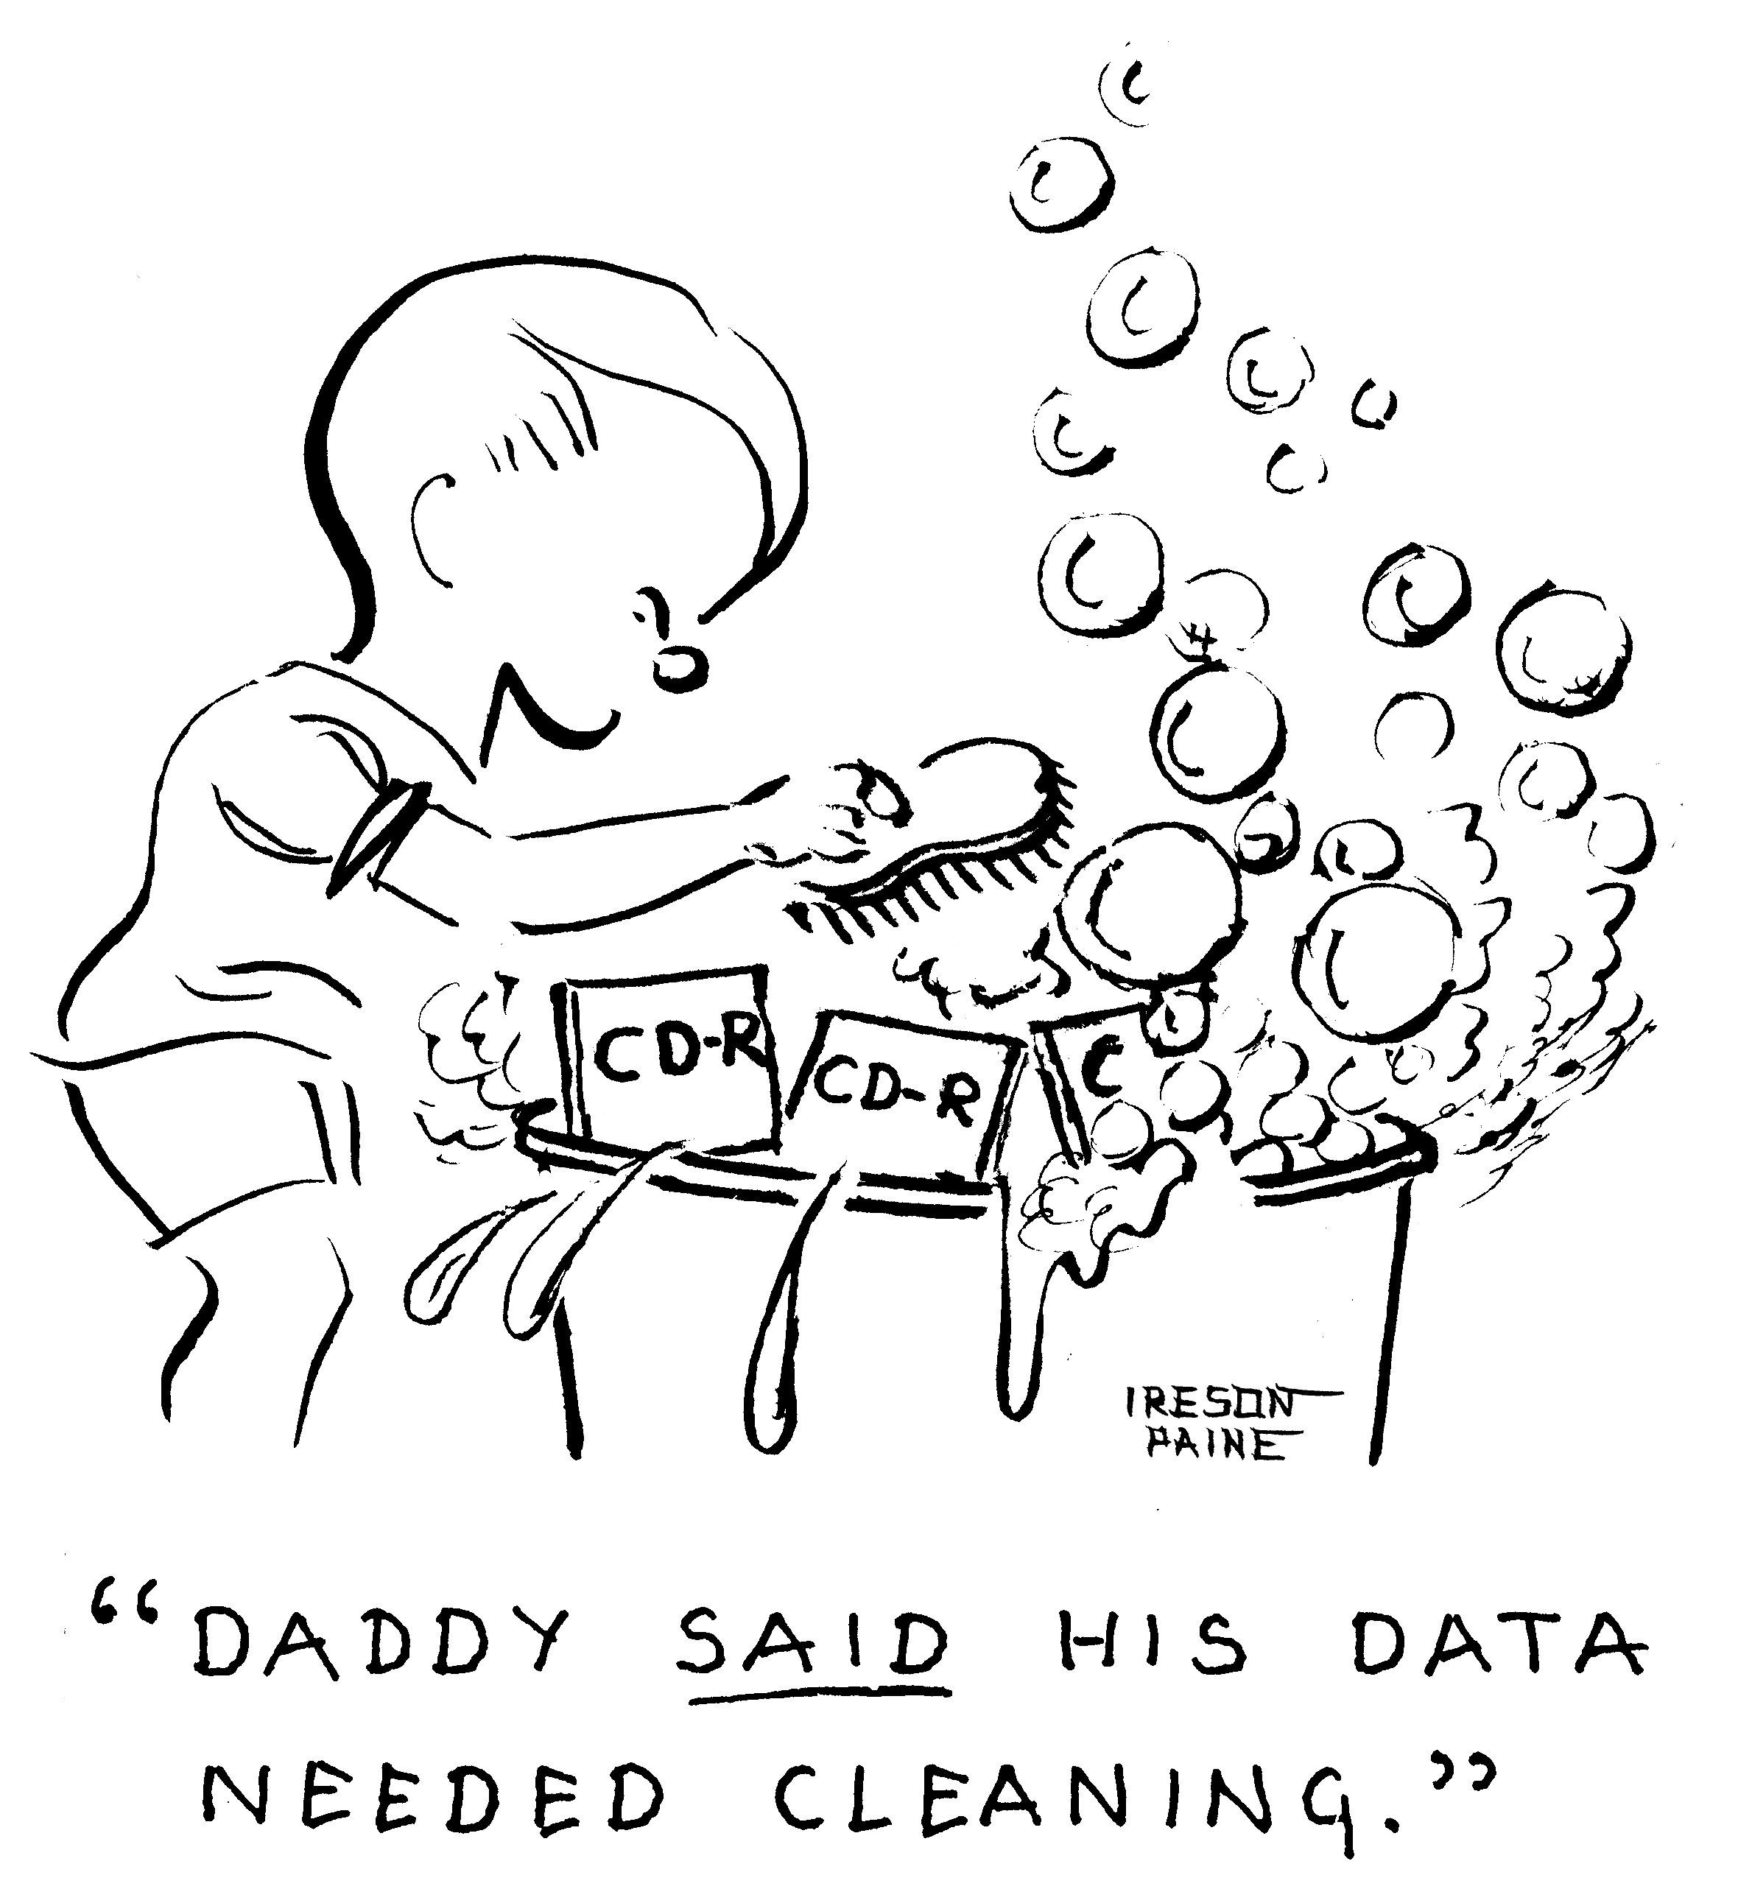

Perhaps this horrible pun is less obvious than the previous ones. Programmers and statisticians often talk about "cleaning" data: the removal of errors and other unusable stuff.

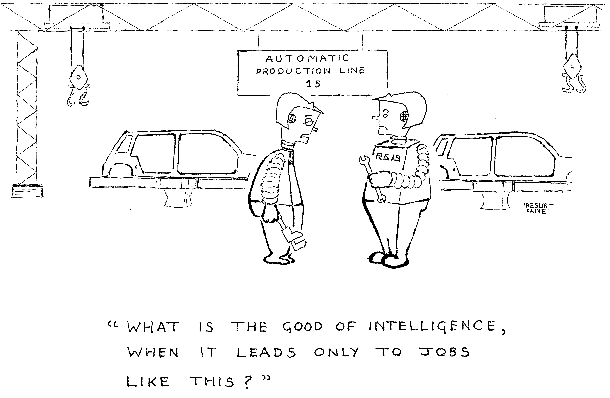

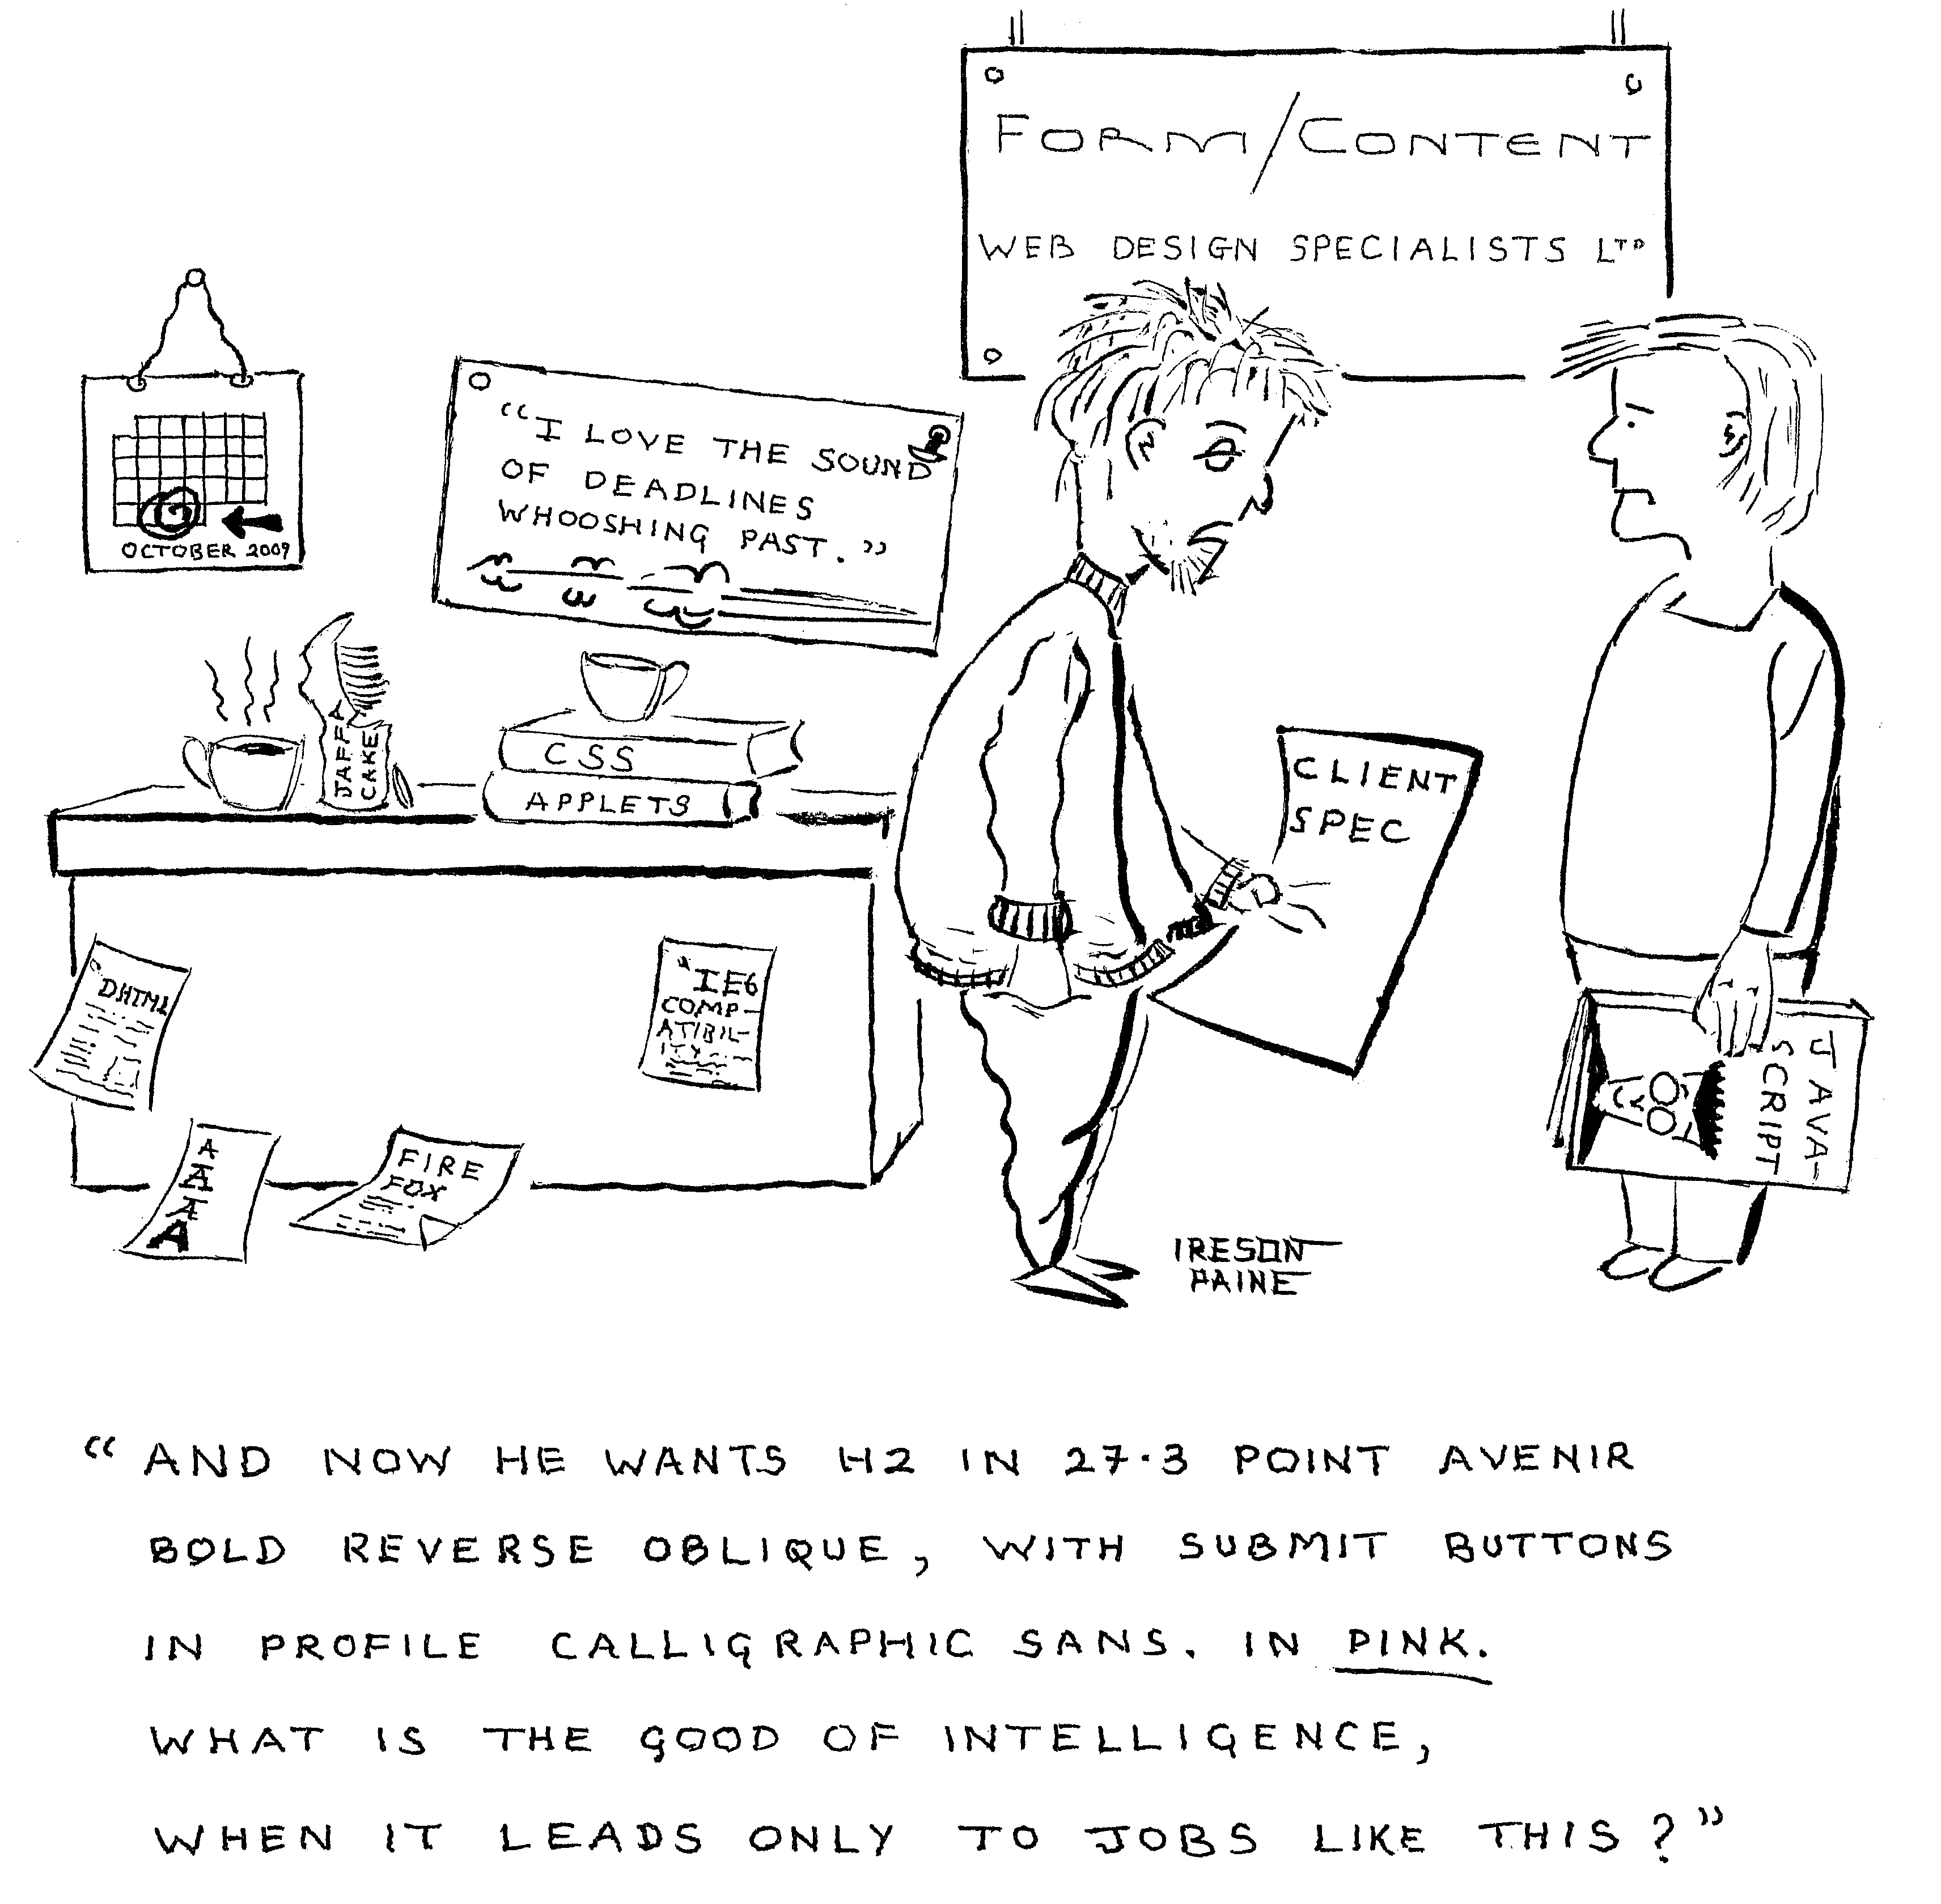

This variant on the previous cartoon was inspired by a company who wanted me to write a program to generate reports in the style decided upon by their graphic designer. This used several typefaces not available on most computers, and a remarkable variety of line spacings, each paragraph seemingly having its own unique layout. It all seemed to be placing too much emphasis onto form rather than content.

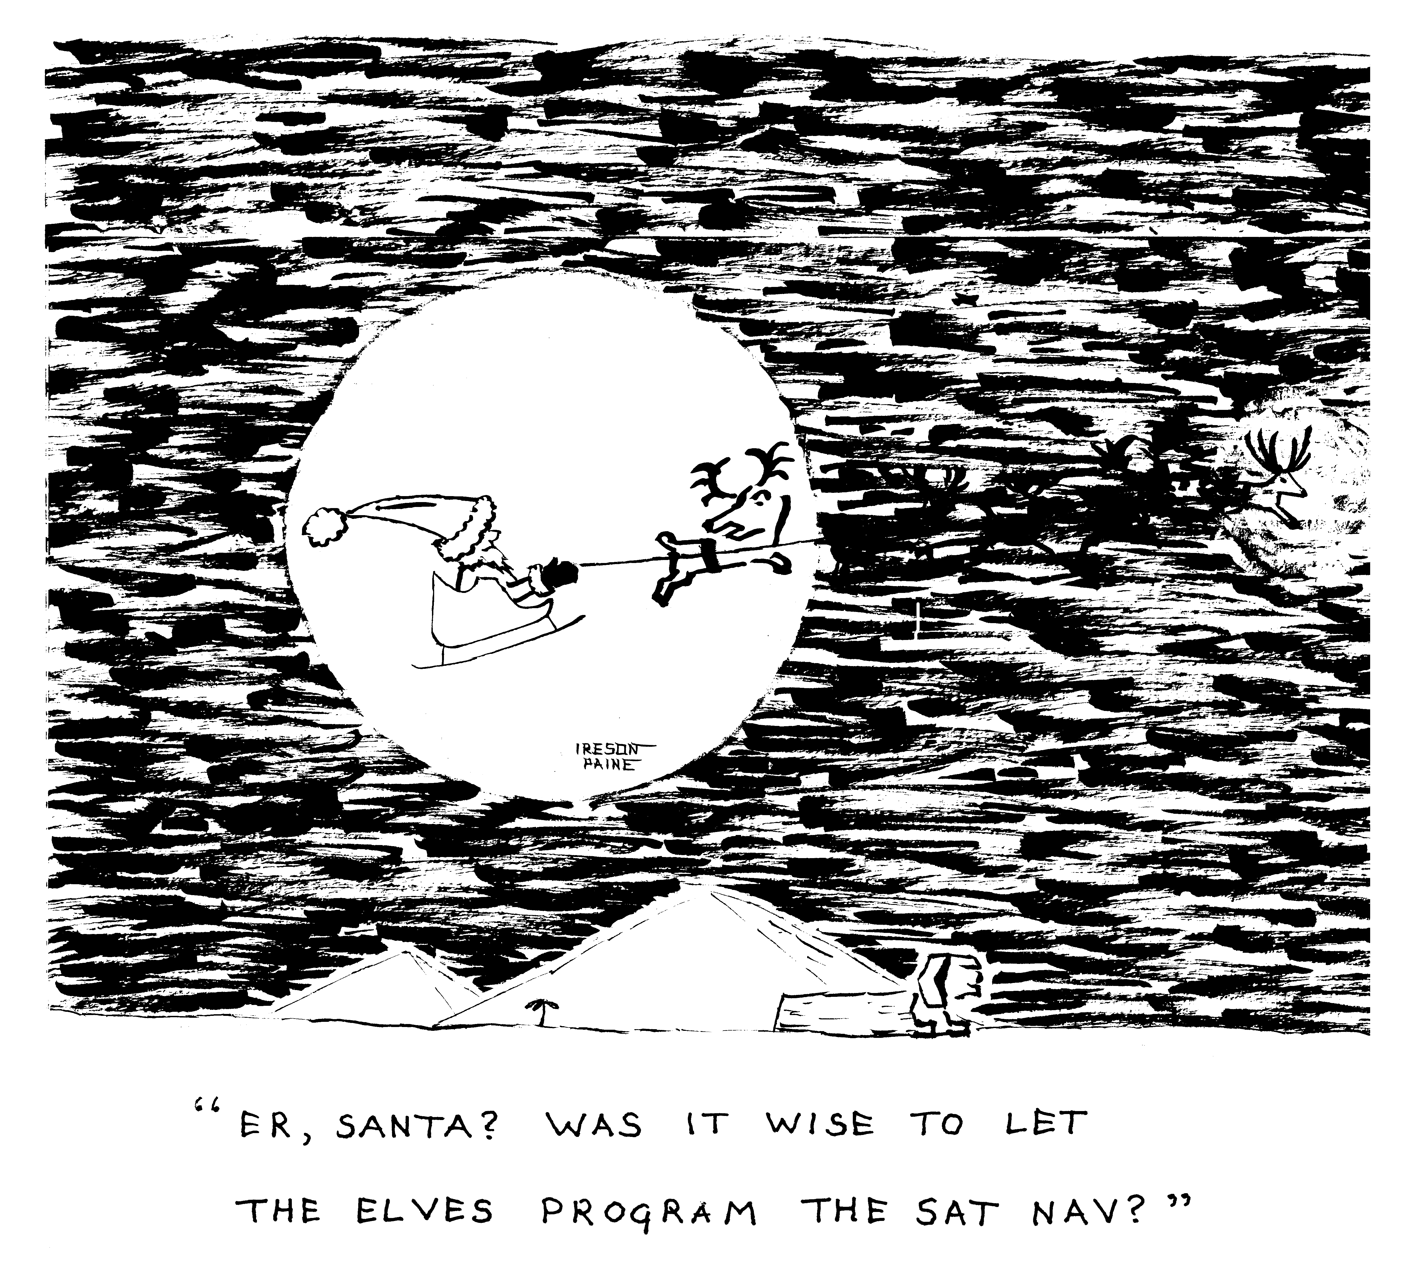

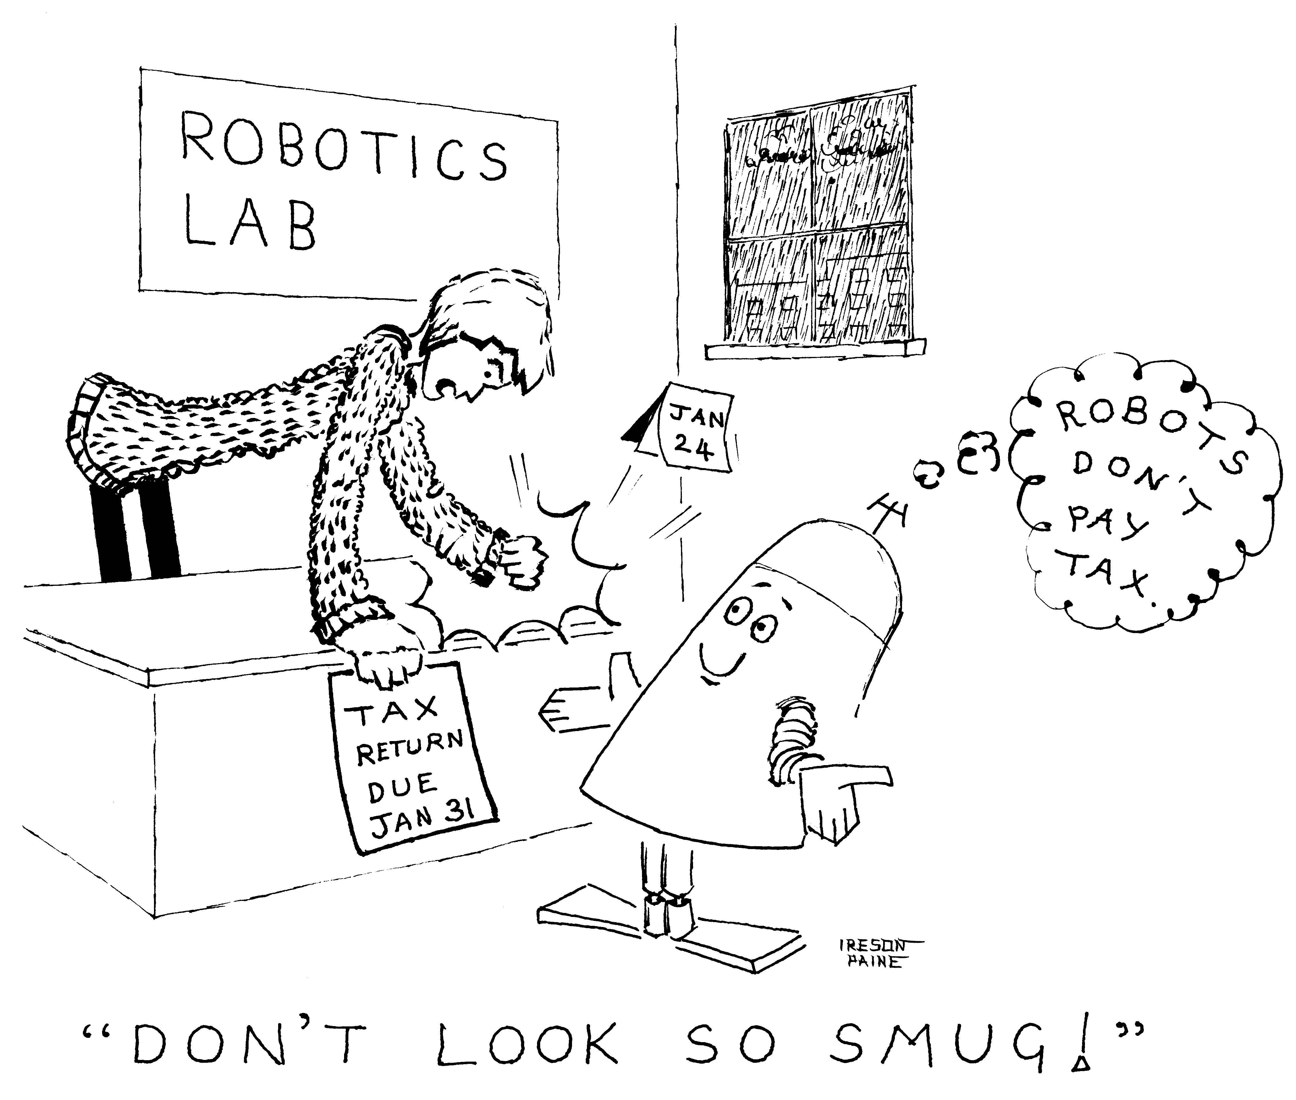

In Britain, January 24th is often said to be the most depressing day of the year, because of post-Christmas debt, horrible weather, gloomy afternoons, and the impending January 31 tax deadline. January is a good time not to have emotions.

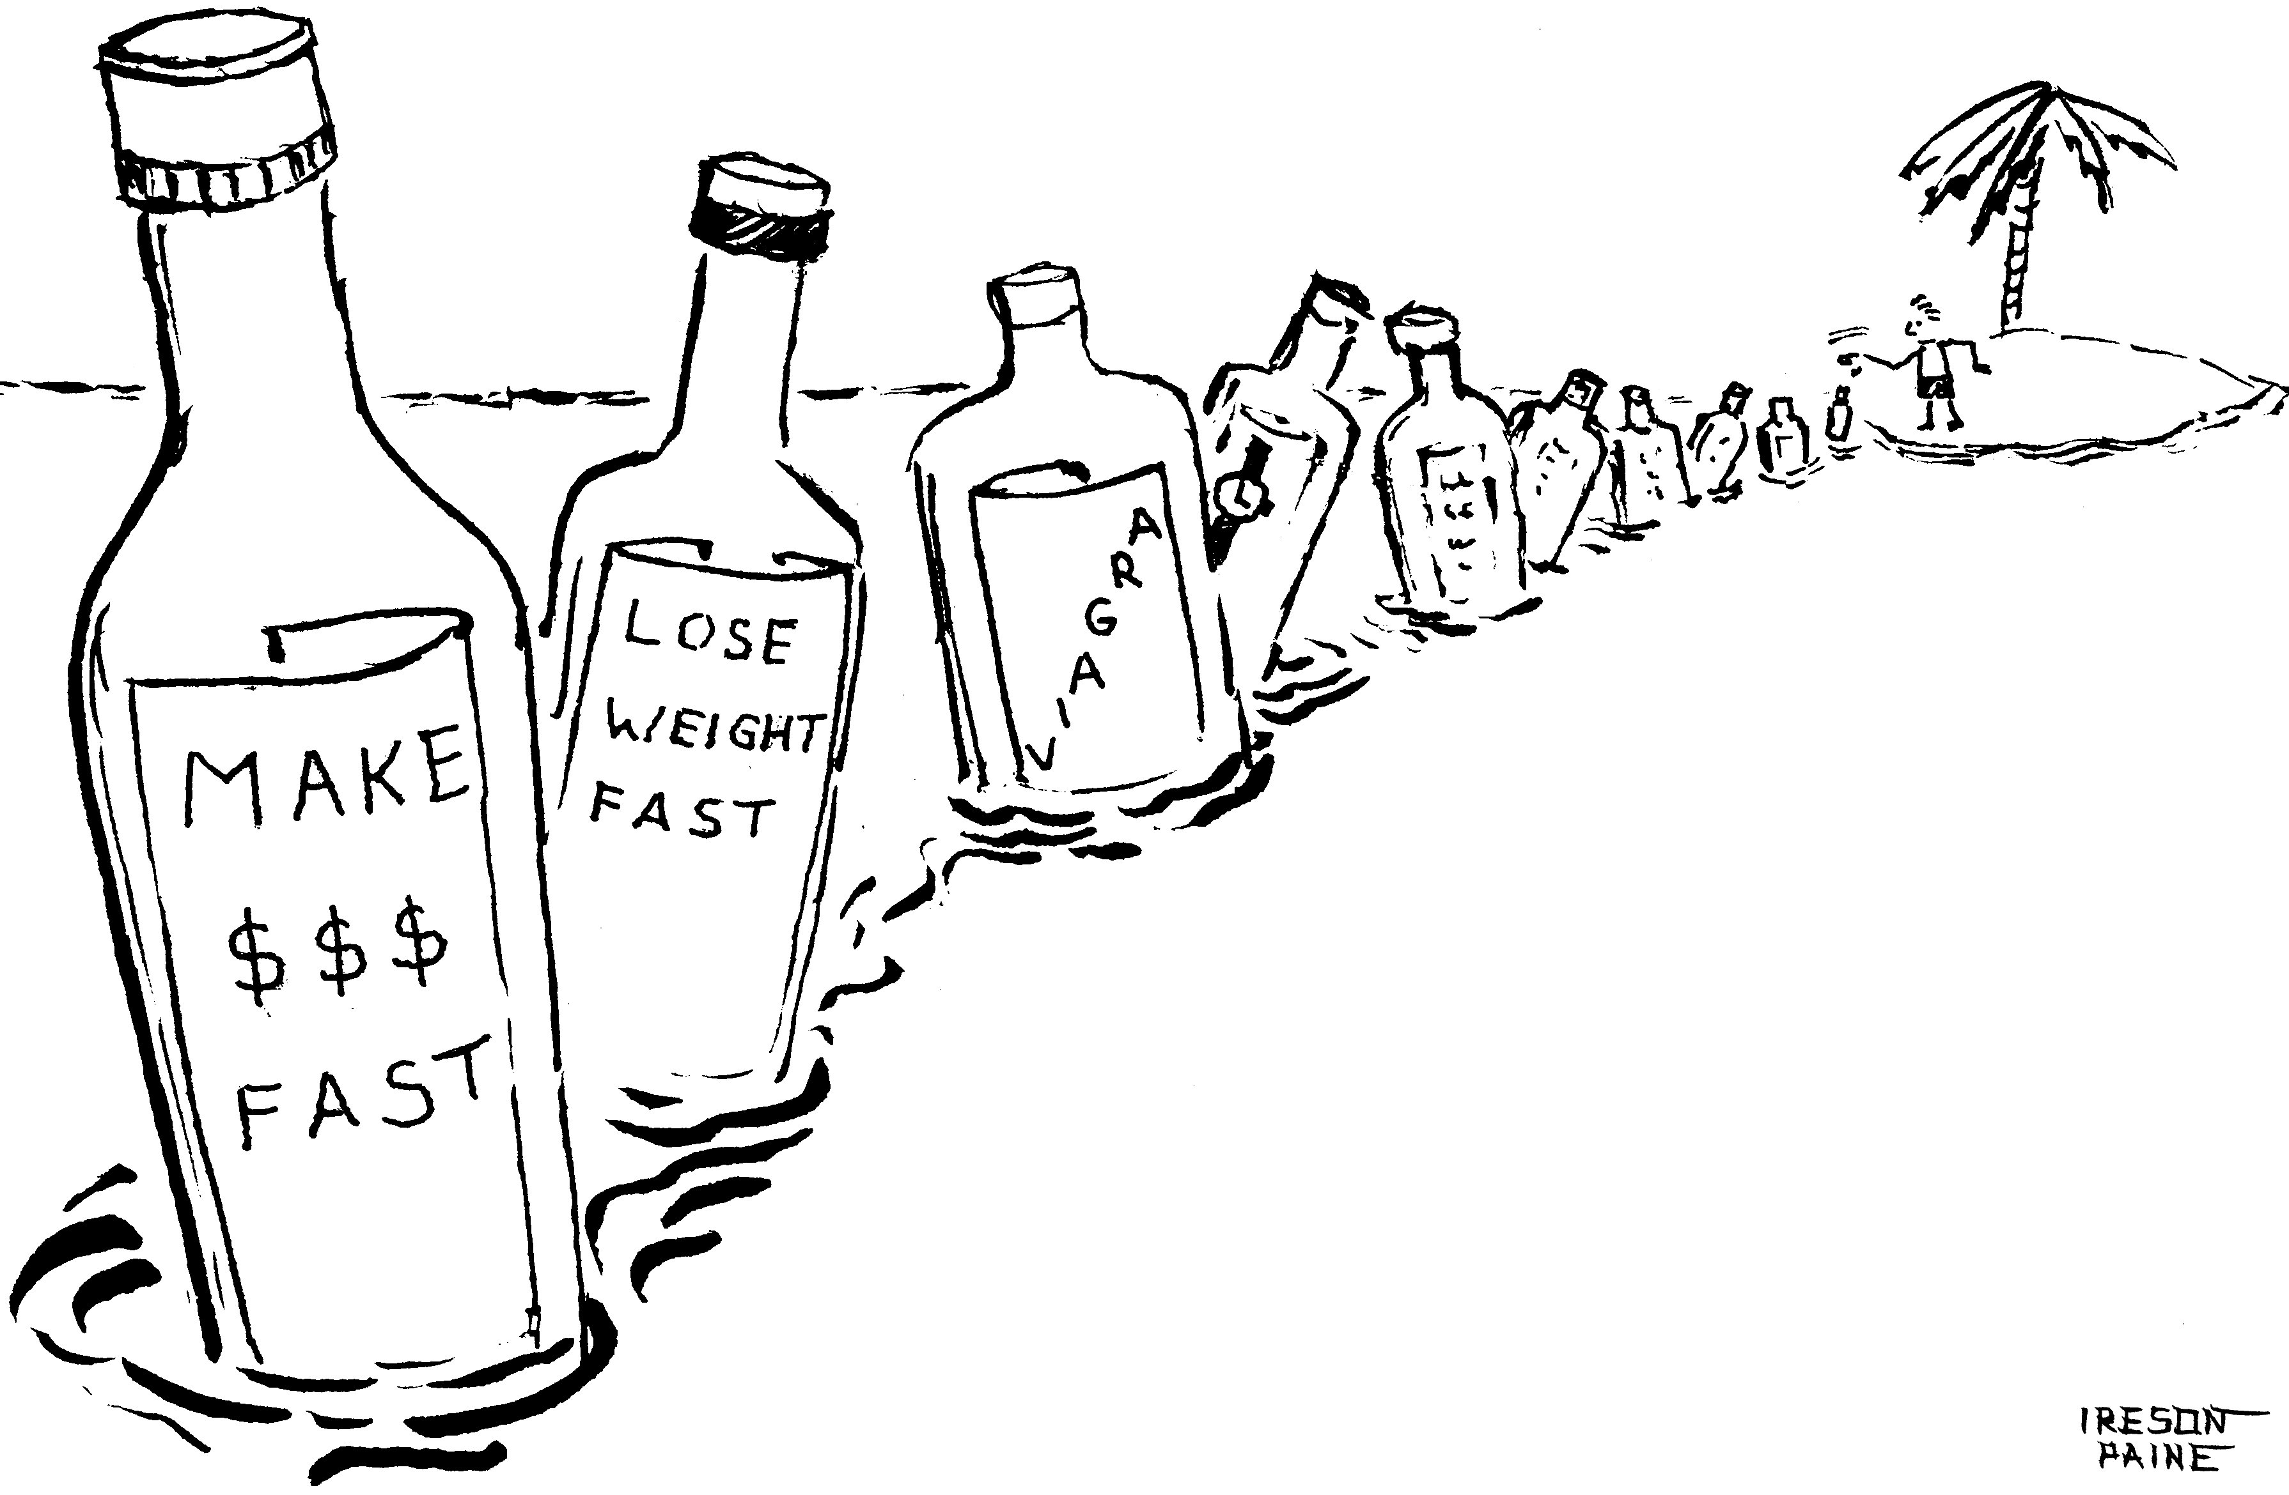

This and the next cartoon are comments on spam. Email spam, I mean, rather than the meat or Monty Python kinds.

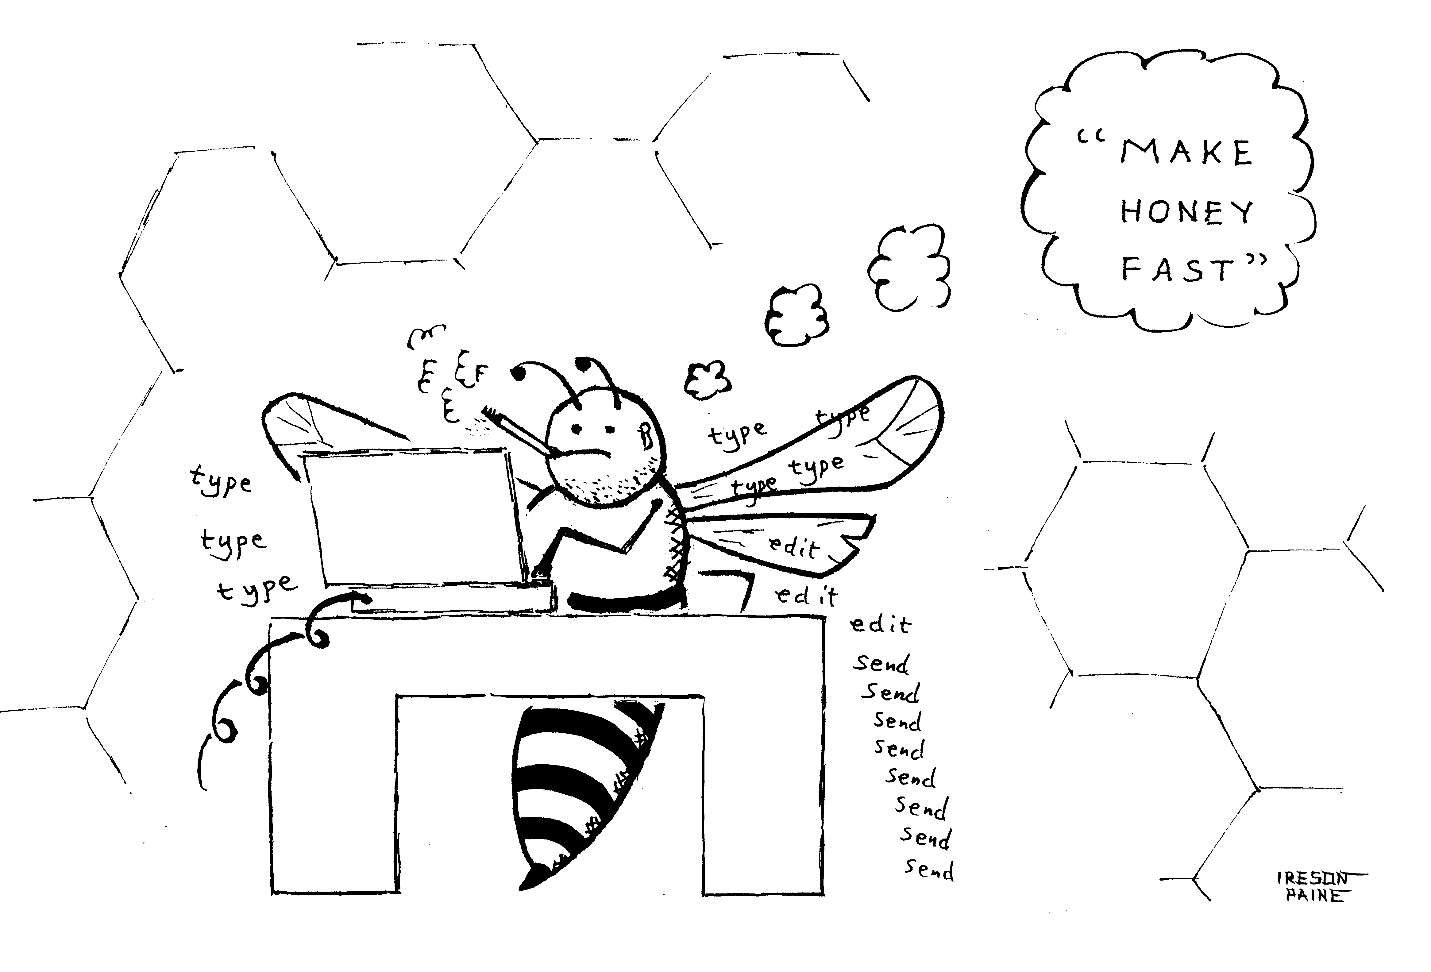

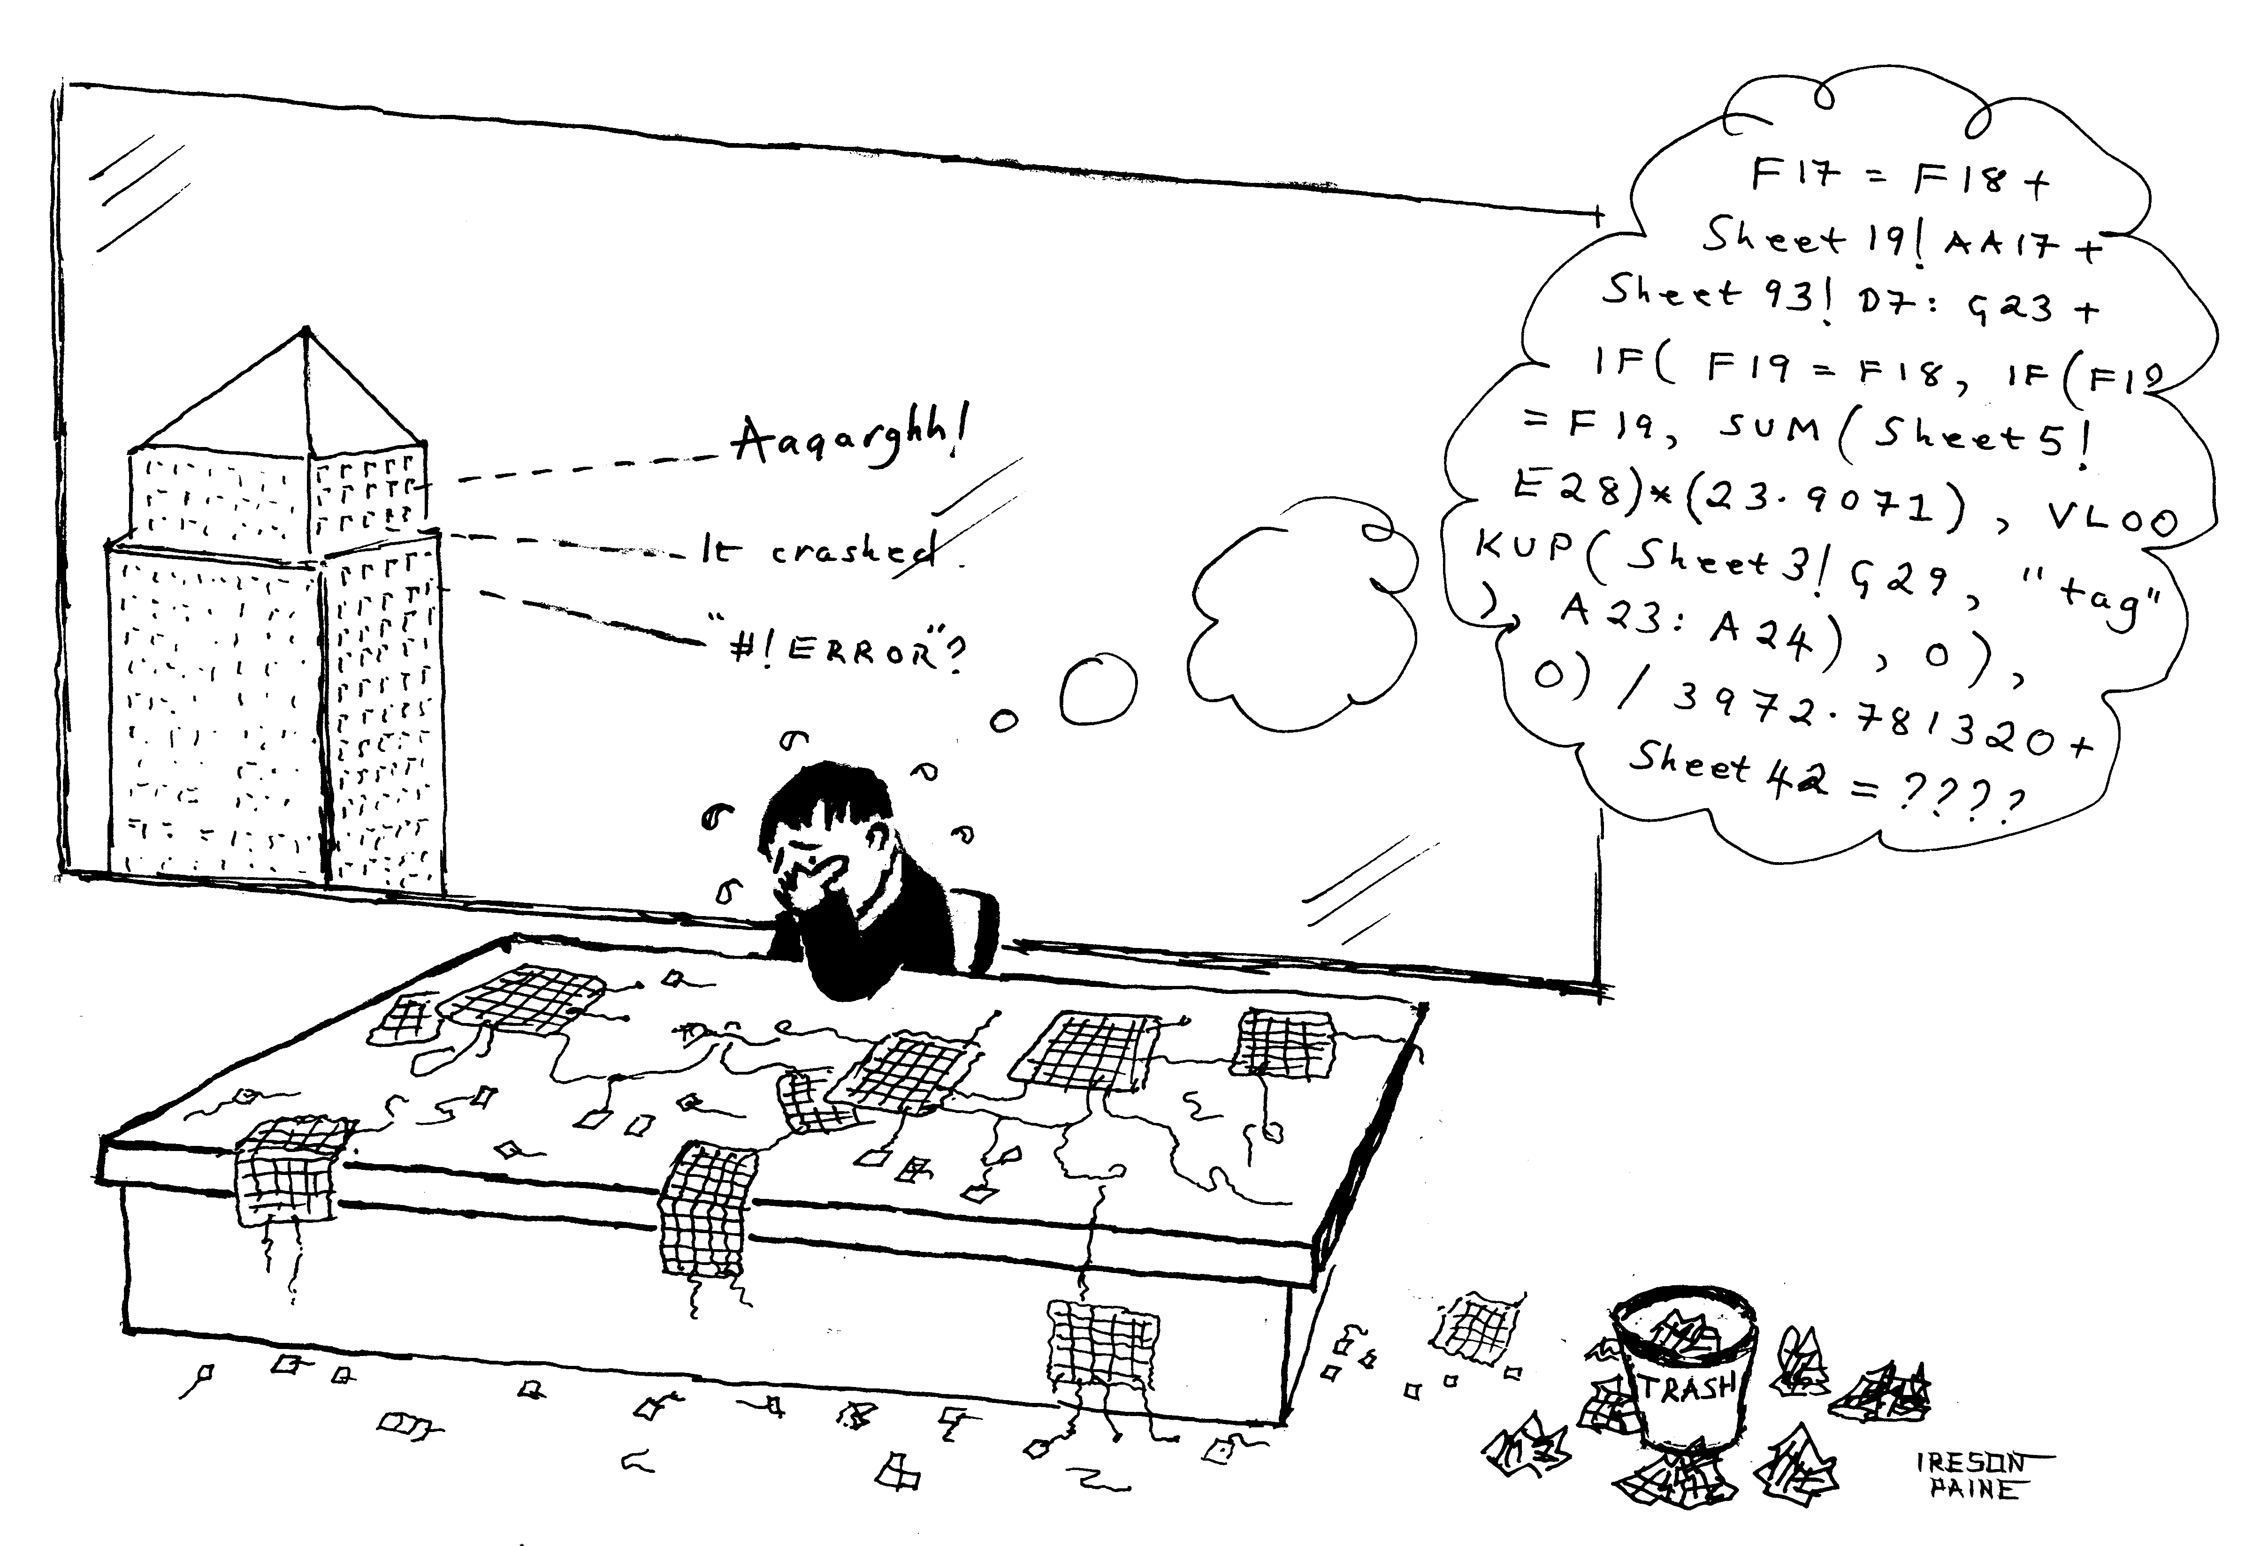

Spreadsheets are remarkably error-prone. One survey, by Coopers and Lybrand, found errors in 90% of the spreadsheets examined. I research into ways of making spreadsheets safer, and drew this for a conference on the subject.

Groggle was an Australian Web service for finding the cheapest alcohol or "grog" in local shops. Its creator, Cameron Collie, found himself attacked by Google, who accused him of violating their trademark. Eric Schmidt is Google's boss; by the way, and Google's informal slogan is "Don't Be Evil". They may not be evil, but they are at least, one might say, mean-spirited.

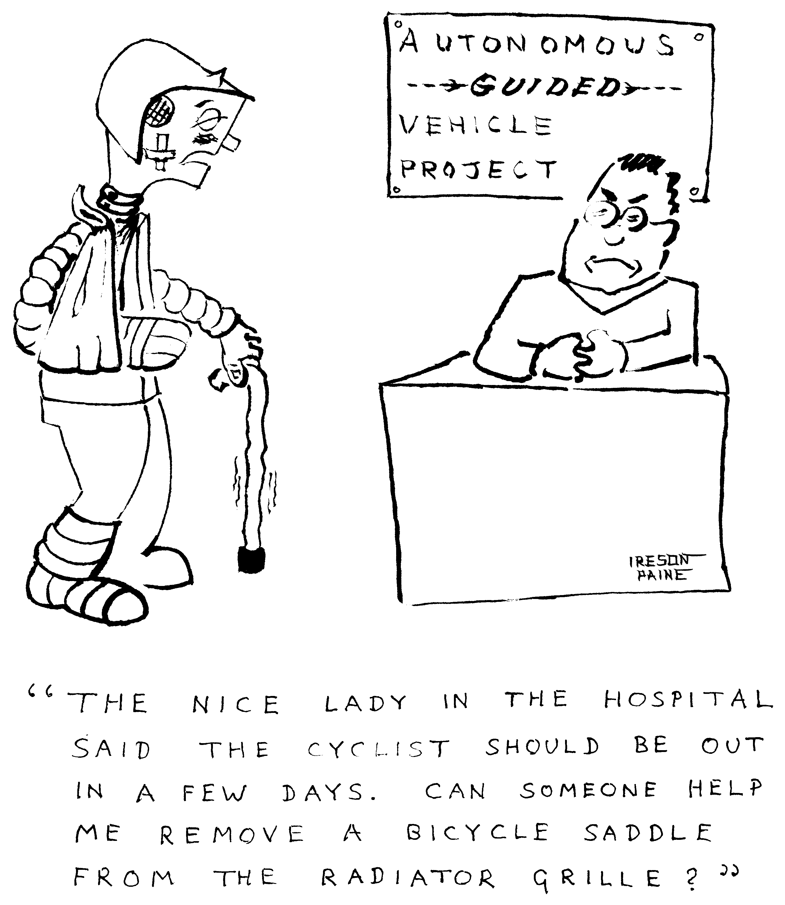

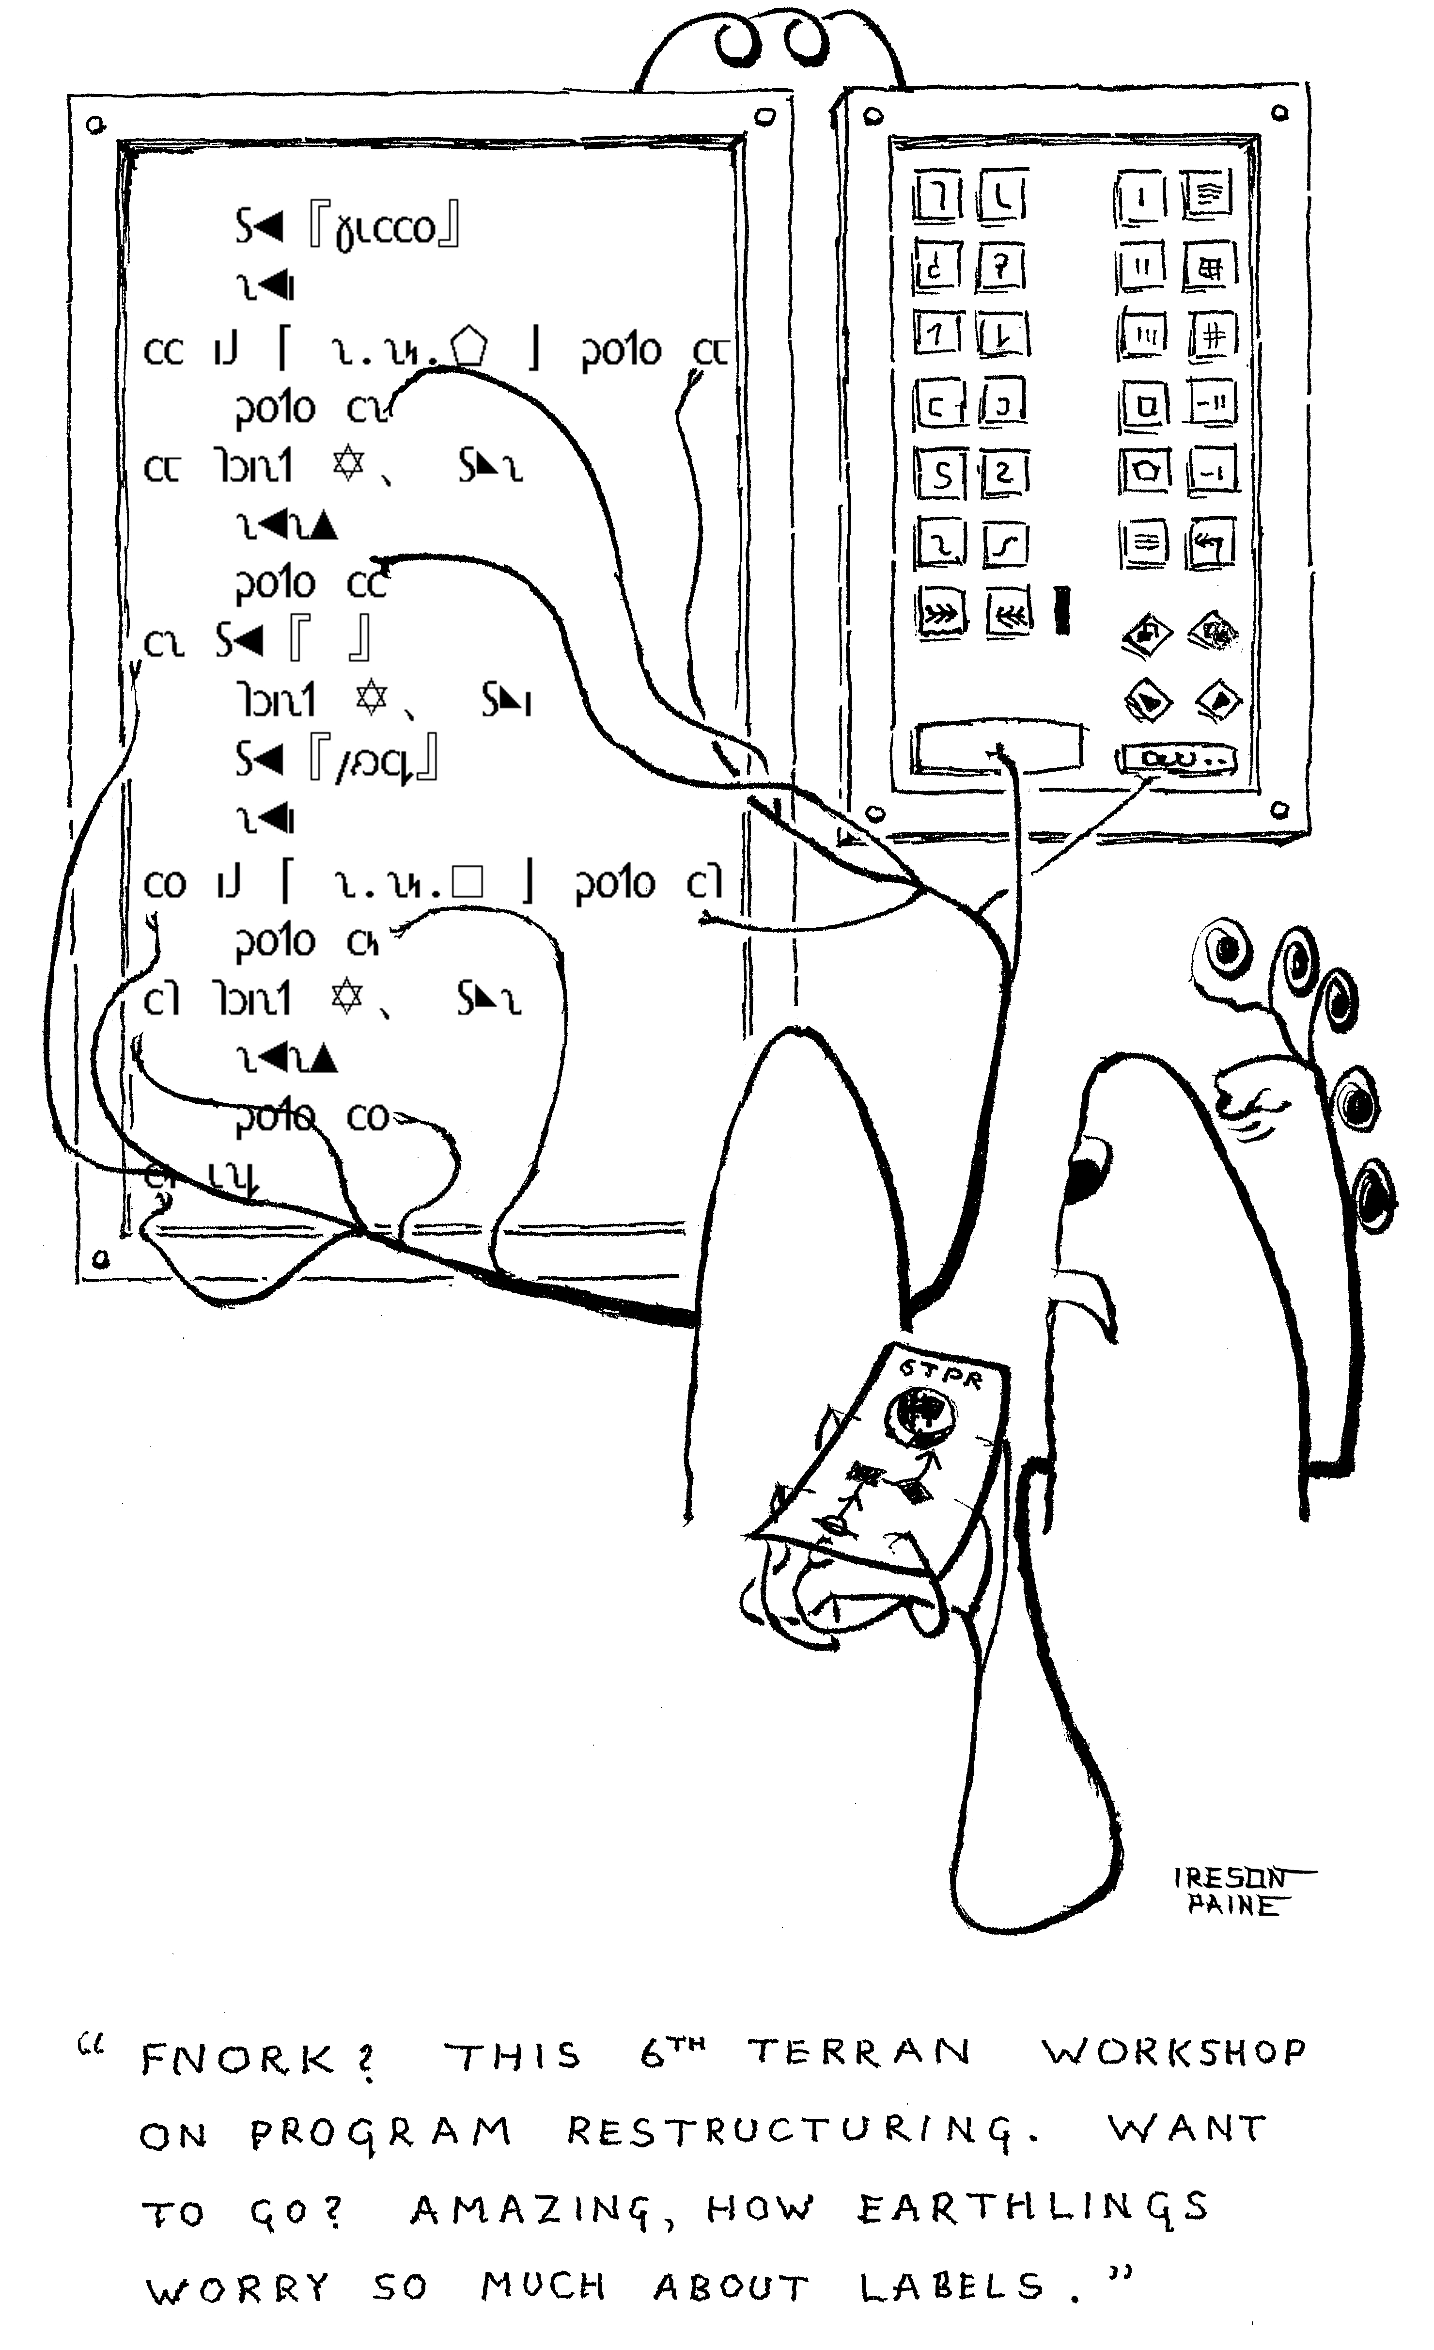

If you had a chocolate-cake recipe that told you how to grease the cake tin, then made you go to page 137 to read about mixing the ingredients, and then jumped to page 46 when explaining how to cook them, it would not be easy to follow. Many computer programs contain "labels" and "gotos", and jump between them so much that they are similarly hard to understand. Indeed, computer scientists abhor labels, so much so that one wrote a letter that's become famous, Go To Statement Considered Harmful. But, I was suggesting, an alien programmer wouldn't mind them, if equipped with enough tentacles to keep track.

Designing the cartoon was interesting. I needed an alien programming language, and didn't want to use an Earthly writing system such as Armenian or Georgian or Telugu. Or Tamil, which I've always thought of as visual jazz, all neon lights and Rhapsody in Blue made graphic. Exotic (and beautiful) as these are, some reader would be bound to recognise them as real scripts. So I decided to use Shavian, created in a competition George Bernard Shaw set up to make a phonetic alphabet for English. The program on the wall-mounted computer is the Shavian equivalent of an Earthly programming language named Fortran. You can find the technical details in my article Unicode and the Shavian Alphabet, at http://www.j-paine.org/dobbs/shavian.html .

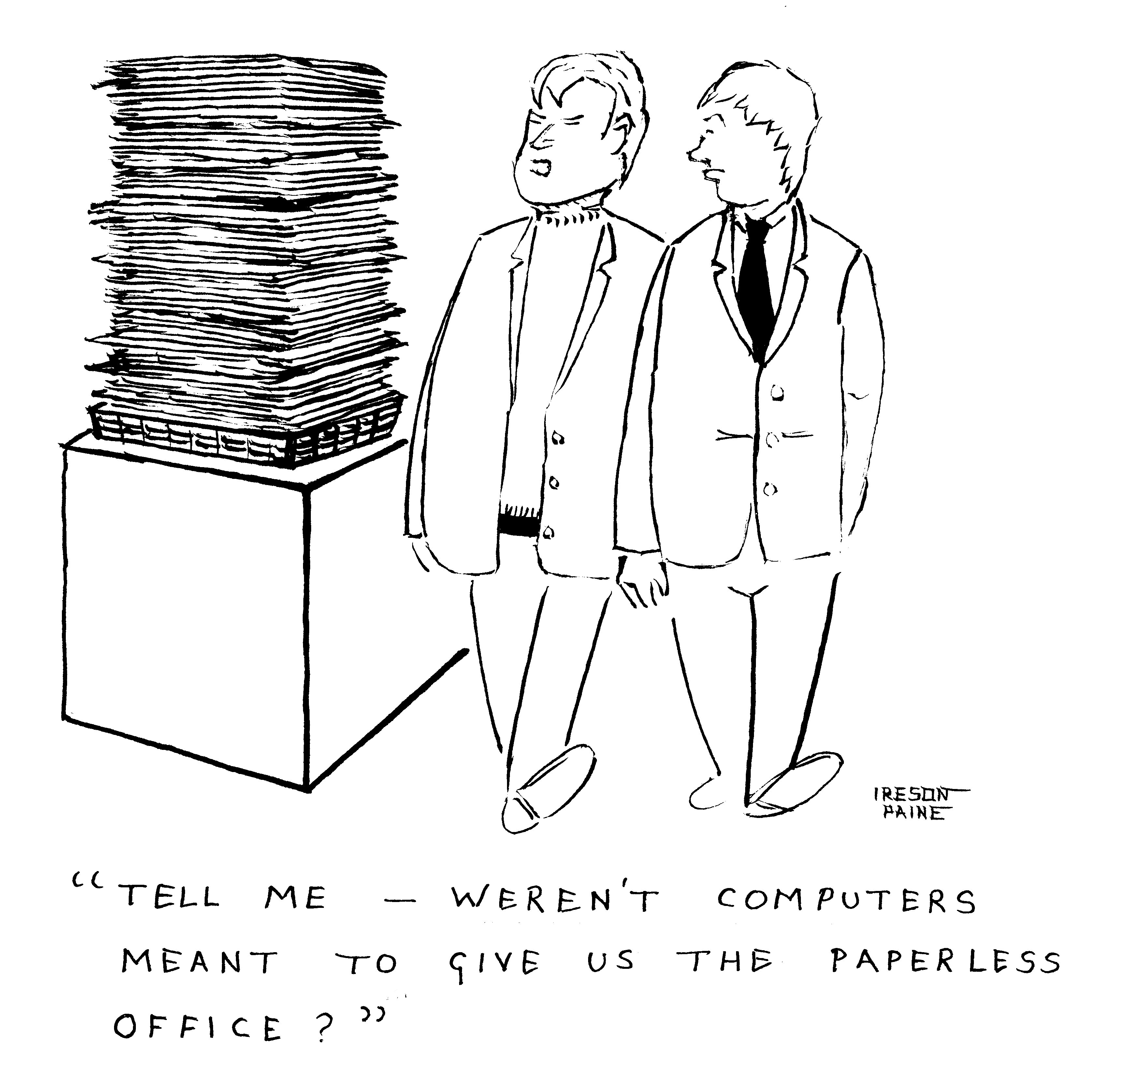

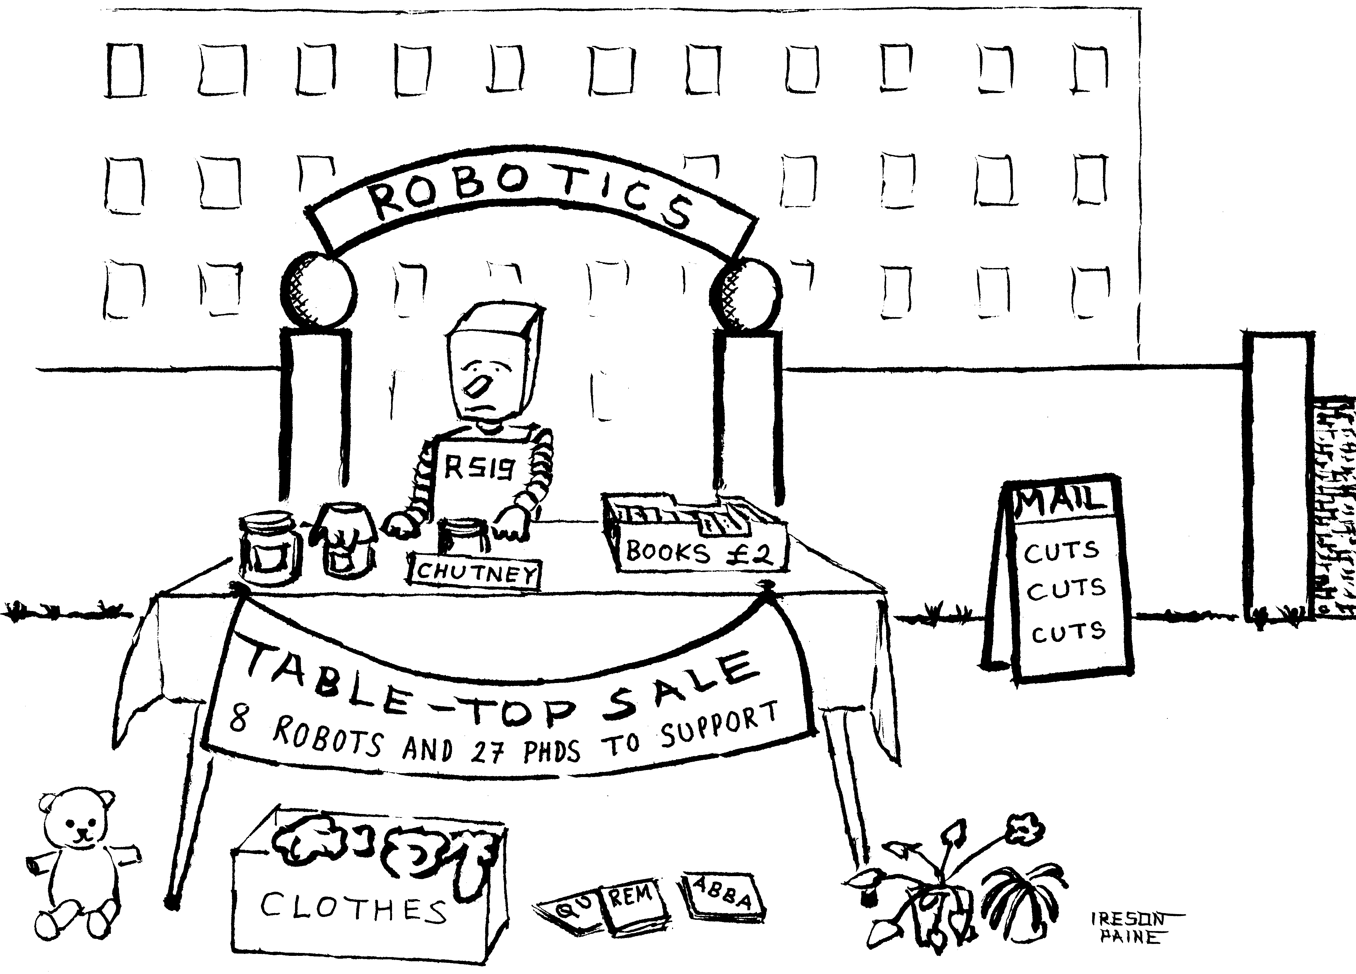

A comment on the post-crisis cuts in research funding.

This is not about computing. It's the frames from a birthday card — front, inside front, inside back — that I was asked to design for an acquaintance who likes wind turbines.

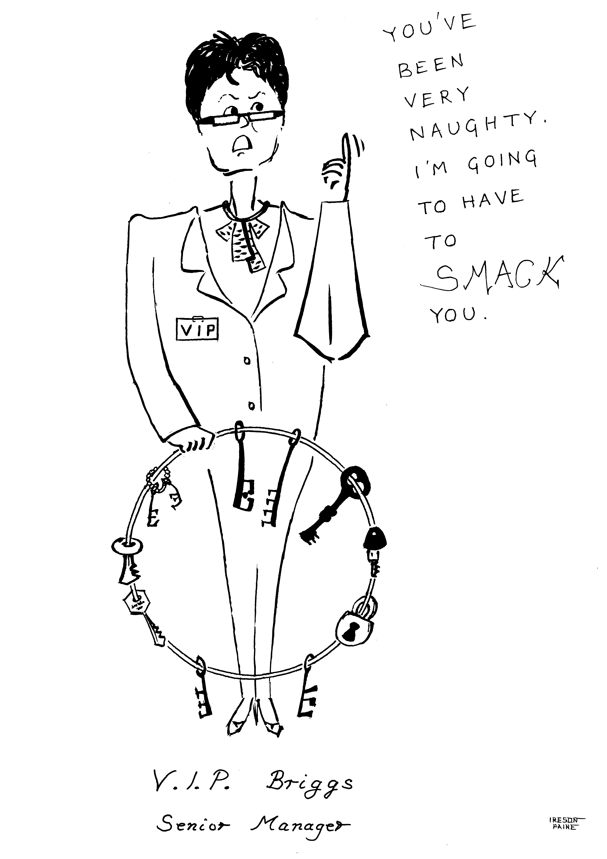

Caricature commissioned of someone’s wife. She’s a senior social worker.



